Vending crib set-up screens
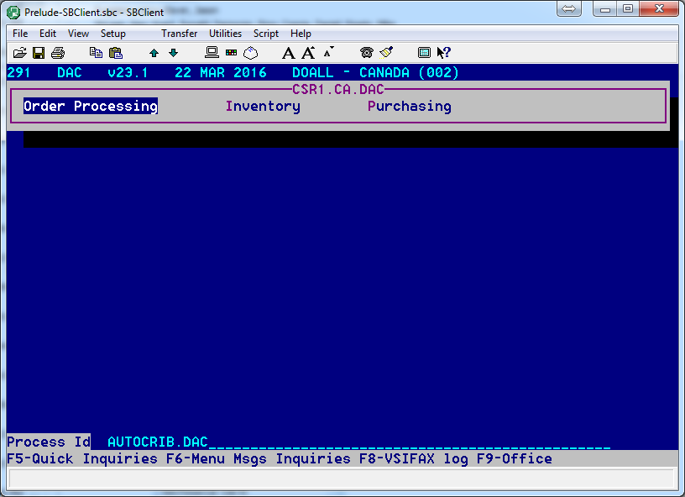
- Go to /AUTOCRIB.DAC

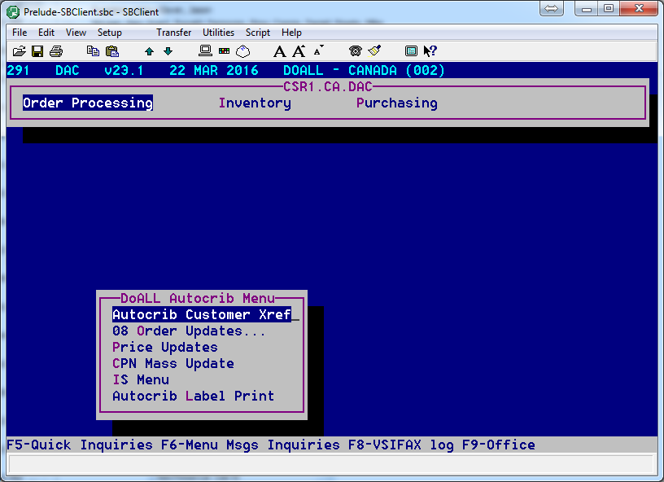
- Click on “AutoCrib Customer Xref”
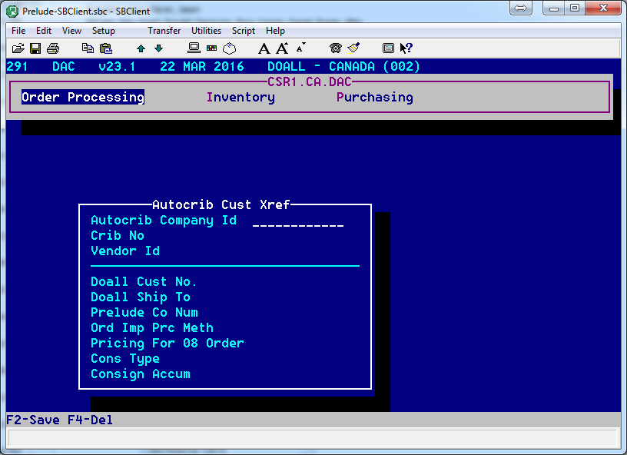
Vending Account Number
Vending Account Number
- Enter all information in each field above
- Final should look like below

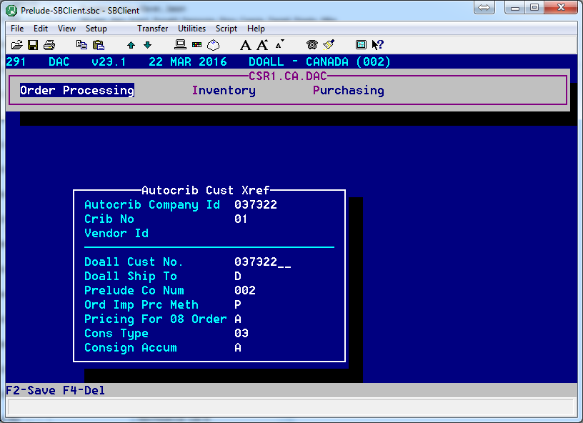
Ship to that needs to be changed where required
Prelude is generating the order
“A” is for AutoCrib pricing rules. “P” is for Prelude pricing rules
Crib Number that needs to be added
- Doall Ship To should be “1” where possible and not “D” for default
  - This is in case there is a billing address as the main address
  - For customer’s that do not have a ship to then “D” is the proper entry
- Cons Typ should be “03”, which is the default
- Consign Accum should be an “A”, which is the default
- Note that older accounts will be set-up with a “C” for Consign Accum
- Press “F2” to save your work

