\*You must have an valid Epicor Learning Center account

1.- Log into Epicor Learning Center

https://ondemand.epicor.com/lms/public/signIn.do

2.- In the menu from the left, go to Assignments / New assignment

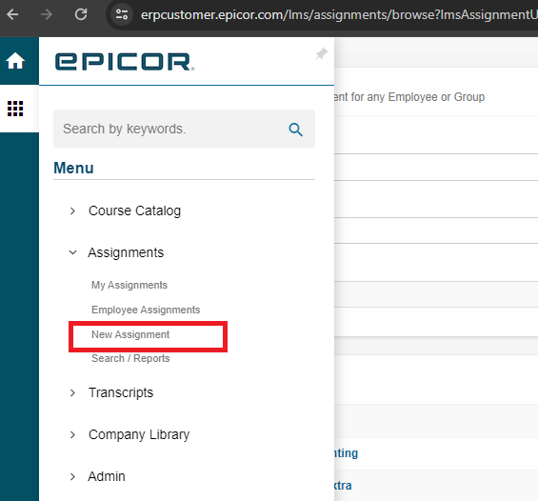

3.- Use filter options to look for the required item, once found click on it’s name

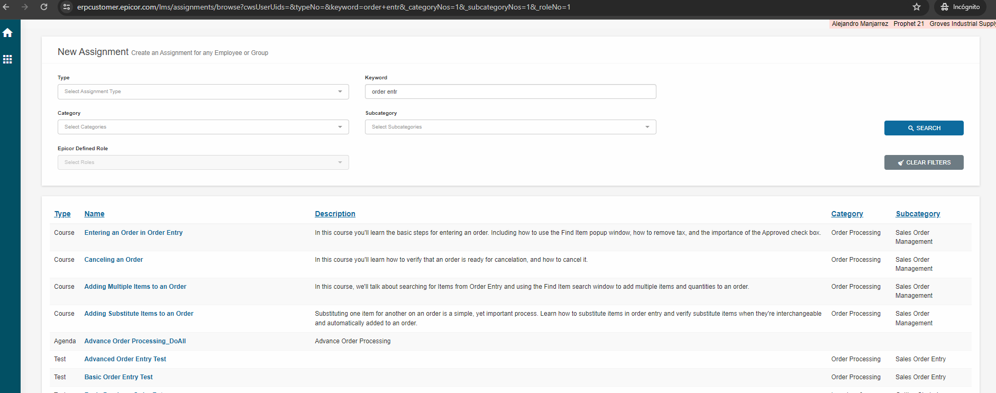

4.- Select user or role to assign

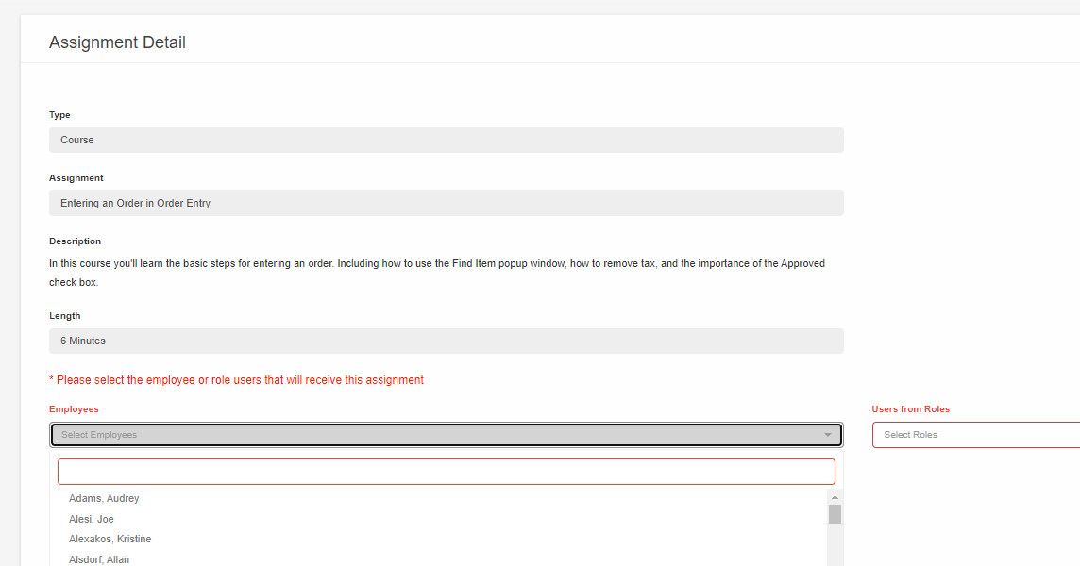

5.- Enter Due date

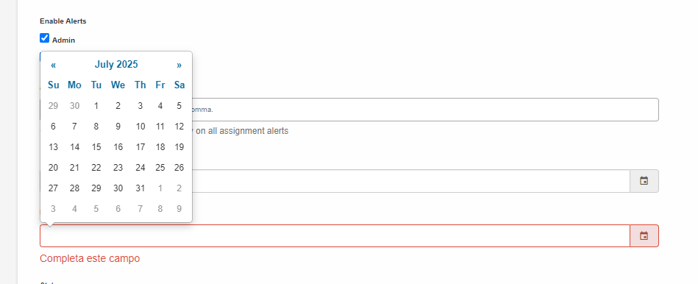

6.- Click submit button at the bottom right.

