Setup Parcel Shipping System (PSS) PC
Build/Setup a standard image GX520 PC per build instructions
- Preferred setup is a Dell GX tower machine with win7x64, 2GB-RAM.
- The PC does not have to be high power. It will be mostly used for SCInet.
- It should be setup so anyone is able to login to it using doall account.
- Disable Standby in control panel Power Options it’s always on.
- Rename the machine to PSS-XXXXXX …where the xx’s is the service tag.
Install SCInet Suite 7.3.1 from \\901file\groups\MIS\Software\PSS NetSuite.
- Setup using defaults and restart PC.
- Hit the “Request Activation Code” when you see the following screen:
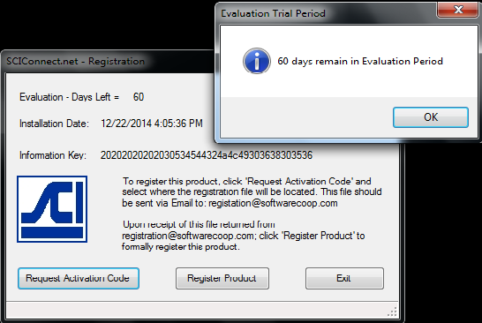
- Register SCInet by emailing registration file to registration@softwarecoop.com.
- Hit “Register Product” to activate file you are given by SCInet.
- Navigate to \\901file\groups\MIS\Software\PSS NetSuite.
- Copy the SCInetSuite.pdf and paste in C:\ProgramData\SCI Net Suite.
- Launch the SCIview.net on start menu.
- Allow Domain networks when firewall security alert pops up.
- Host IP is 10.1.3.5
- Go to Setup on start menu and select Display Parameters.
- Select Display Font and change to Size 14. Nothing else needs to change.
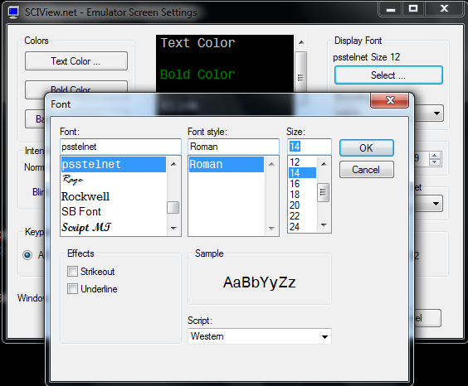
- Select “File” from top menu and select “Settings” > “Save Current Settings”
- Save as “DoALL PSS” at default file location.
- Create a shortcut to DoALL PSS to Users > Public > Desktop
- Email registration@softwarecoop.com any time a license becomes free (ie machine breaks).
Install UPS label printer
- If this is a new station, find an available IP address to setup for location.
- Request a queue to be setup (provide IP address) for the station from Jeff Noble.
- For Zebra label printer, Connect network cable and setup the IP address on unit.
- Change “Print Method” to “Direct-Thermal.”
- For smaller units such as ZP450, you’ll have to setup from it’s web page.
Test the Connection to the SCInet Suite
- Follow PSS Documentation instructions.
- Login using any available PSS windows login (ie packing station 0901, DP901).
- Select 7. System maintenance Menu then 1. Station Devices Entry.
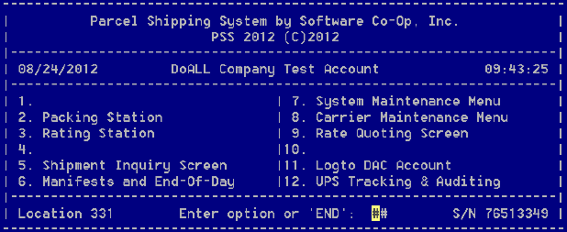
- Select 2. Terminal Setup and type T to test.
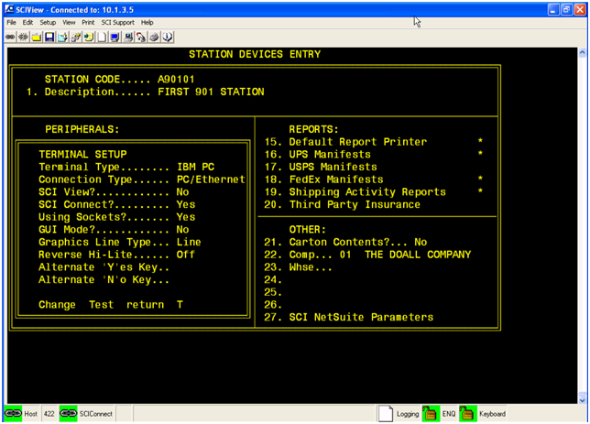
- You should get “SCI View test has PASSED!...”
Test serial connection to scale
- In system tray, right click SCIconnect.net > select “Serial Communications Setup & Test.”
- The default settings should work.
- Select the scale from Scale Type and hit Read Data.
- Rcv Data should be same reading from scale LCD.
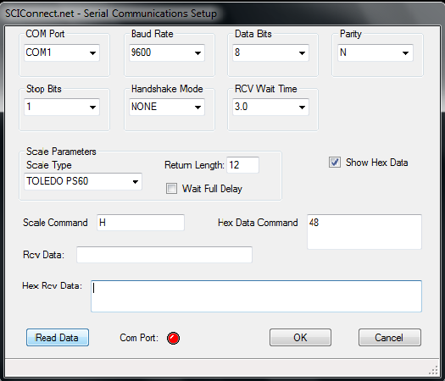
-Hit Ok to exit the window.
Test Scanner and Scale
- Follow PSS Documentation instructions.
- Borrow pick ticket from shipping and use the scanner to scan the barcode.
- Press 1 for picking the weight from scale automatically.
- Everything should work.
If anything should fail, try the instructions again.

