Inventory Correction Procedure

“Found Inventory” Process:

Step #1 – Log into Autocrib
Step #2 – Go to Transactions / Physical
Step #3 – Select the Crib
Step #4 – Select the Bin
Step #5 - Select “Physical”
Step #6 - Enter the found Inventory quantity into the “On Hand” location
Step #7 – Enter “FOUND INVENTORY” into the comment field
Step #8 – Select “Ok”
Repeat steps 3 thru 8 for all “Found Inventory”

Missing Inventory Process:

Shrinkage Employee Set-Up

- If not set-up please contact APS to have employee set-up

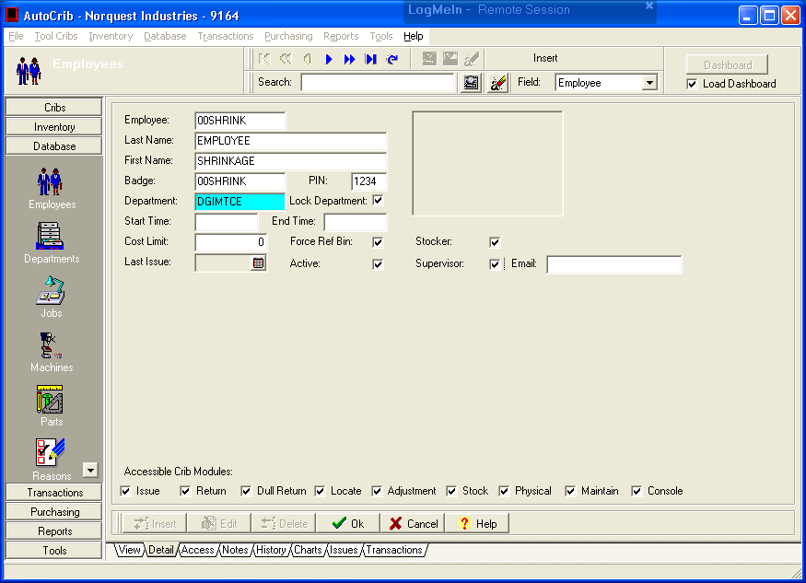

Issuing out Missing Product:

Step #1 – Log into Autocrib
Step #2 – Go to Transactions / Adjustments
Step #3 – Select the Crib
Step #4 – Select the Bin
Step #5 - Select “Adjust”
Step #6 - Enter the missing inventory as a negative value (-1)
If “Onhand” stock is missing – Populate “Quantity” Field
If “Burn” stock is missing – Populate “Burn” Field
Step #7 – Enter “Inventory Correction” into the comment field
Step #8 – Select “Ok”
Repeat steps 3 thru 8 for all “Missing Inventory”

