Autocrib Inventory Count Process

TWO Weeks Prior to Count:
- TSR to notify the Champion at the account to let them know that there will be a service disruption on the scheduled day of the count.
- Review of Open Orders – Make sure Prelude matches Autocrib
- Check printer paper in server cabinet

Day of Inventory Count

Prior to starting:
- CSC to notify the Champion of the start time (Please give them enough time to warn their people to take what they need before you start)

Notes:

No transactions can be processed during the count of each crib. This rule starts the minute the count sheets are printed and ends when the count is completed

Only print count sheets for one crib at a time

Counters – must sign and date the first page of each cribs count sheets

Inventory Count Process:

Step #1 – Go to the Mgmtstation
Step #2 – Log in
Step #3 – Go to Reports / Standard / InventoryStep #4 – Select the correct report:
- Physical By Robo – For all Robocrib’s
- Physical By Vending Crib – For all other equipment
Step #5 – Enter Crib Number into the “From” and “To” field in the Crib Selection area

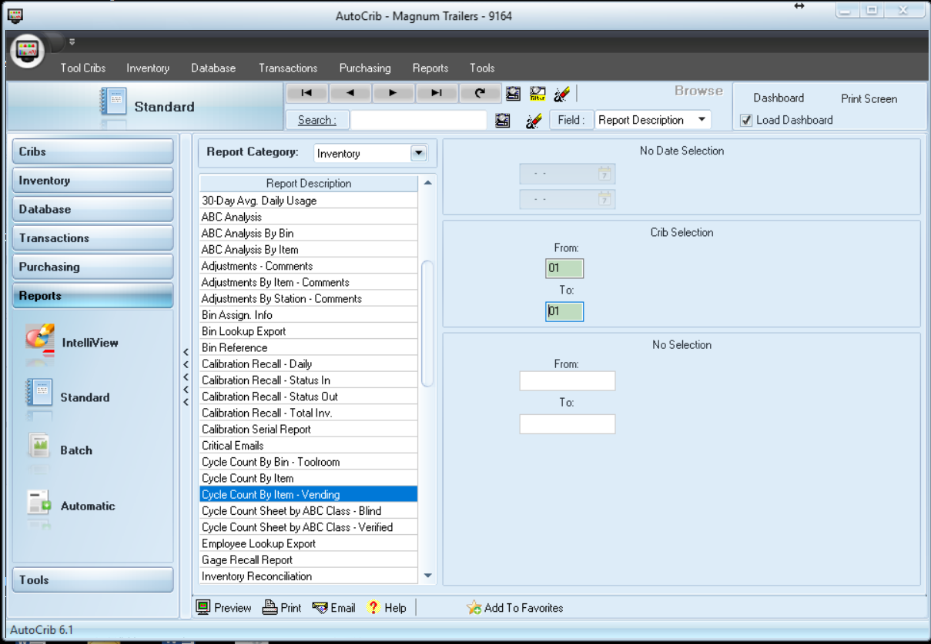

Step #6 – Print off sheets
Step #7 – Go back to vending machine
  - Restart RoboCrib Software
Step #8 - Open control panel door (R2K Only. Skip to next step for all other equipment)
  - Put switch for doors into “Test” mode
Step #9 – Log into RoboCrib Software
Step #10 – Select “Physical”
Step #11 – Select “All”
**** Robo Crib with filler bins count sheet don’t all start on the first page. You may have to skip a few pages to find the first bin that the Robo Crib pulled up. Don’t worry, the machine will bring up all the skipped bins towards the end of the count ****

Step #12 – Start the count

Notes: You must physically check every item in each bin to ensure that the correct item and quantity are located inside. Please note all descrepancies on the count sheets

Step #13 – Once completed
  - Log out
Step #14 – Put door switch back to “Run” mode (R2K Only. Skip to next step for all other equipment)

Repeat Steps 1 thru 14 for each piece of equipment.

Step #15 – Double check all descrepnacies
Step #16 - Follow the “Inventory Correction Procedure” listed on separate document
Step #17 – Notify the “Inventory Manager” of completed count
Step #18 – Give or Send count sheets to “Inventory Manager”
- (Branches to send with weekly inter-office mail shipments)

