Receiving – Elevend
Step #1 - Go to Management Station
Step #2 - Sign in to AutoCrib Software
Step #3 - Go to “Reports” Module
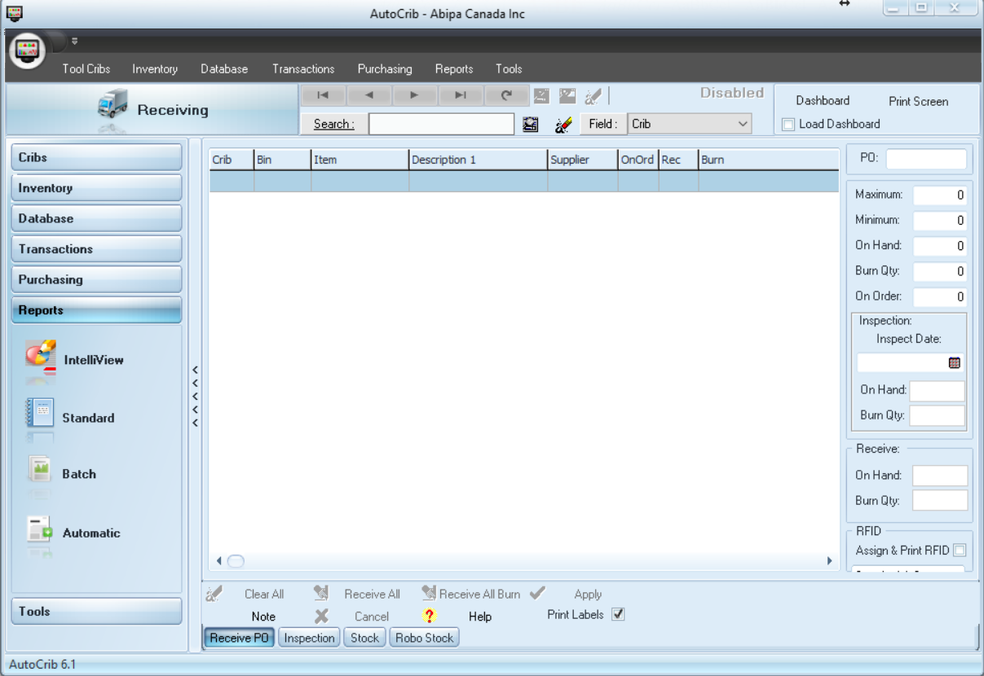
Step #4 - Select “Standard” Function
Step #5 – Select “Purchasing”
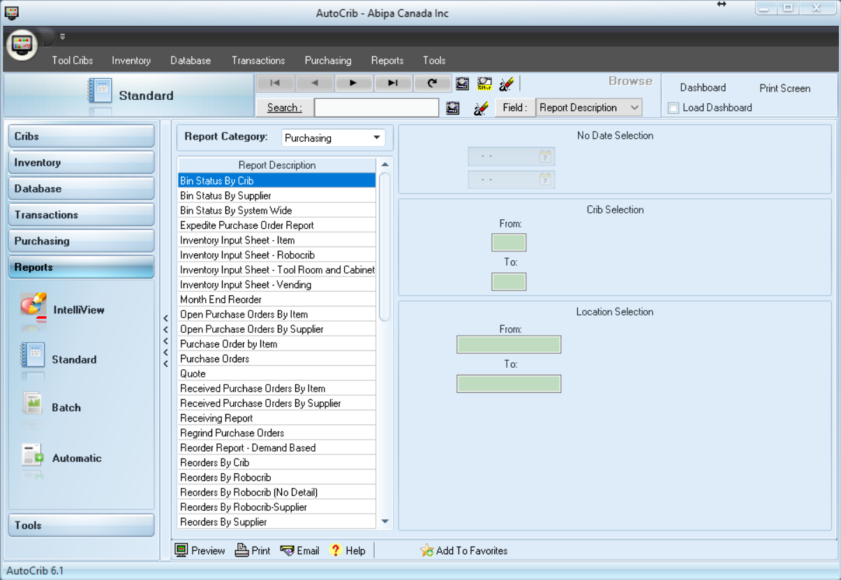
Step #6 - Select & Print “Inventory Input Sheet – Vending”
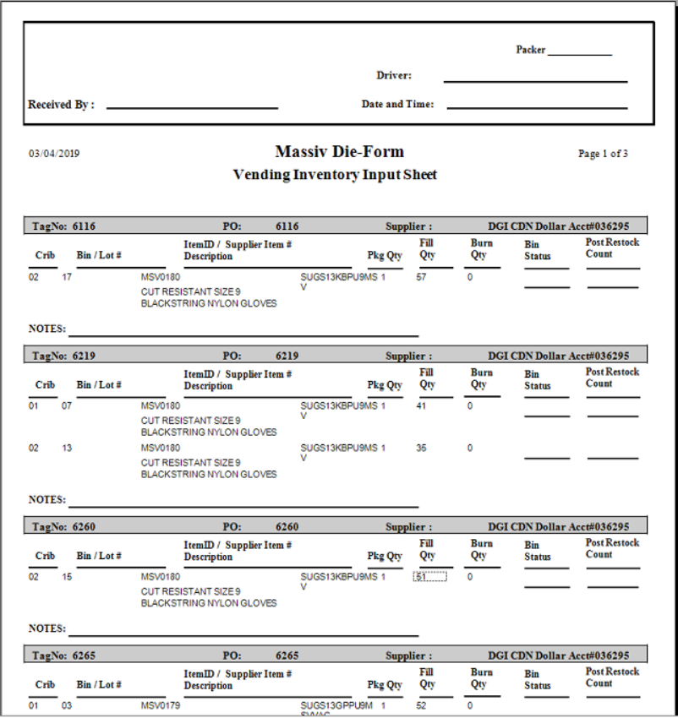

Step #7 - Place prelude packing slip information on to Inventory Input sheet
  - This will help determine how much stock goes in each crib bin (If there is multiple bins setup)
Step #8 - Go to the Elevend Terminal
Step #9 - Select “Tags”
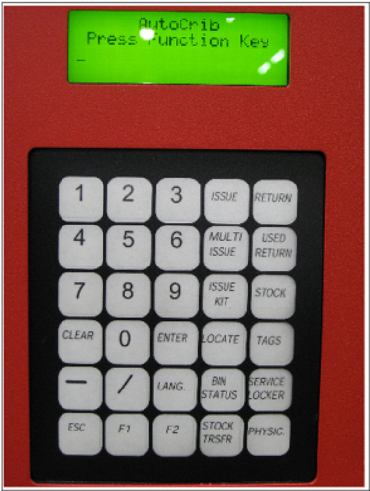
Step #10 - Scan or Enter your “Badge”
Step #11 - Enter “Tag” Number
Step #12 - “Tag” Complete
Yes = 1
No = 2 (If no is selected, follow the prompts on the screen)
Step #13 - Once door open, place the appropriate item into the bin
Step #14 - Close the door and stock the next bin
