RoboCrib – Receiving (On Hand & Burn)
Automatic Receiving Process - ScaleMate
Step #1 - Login to the Vending Machine
Step #2 – Select “Stock”
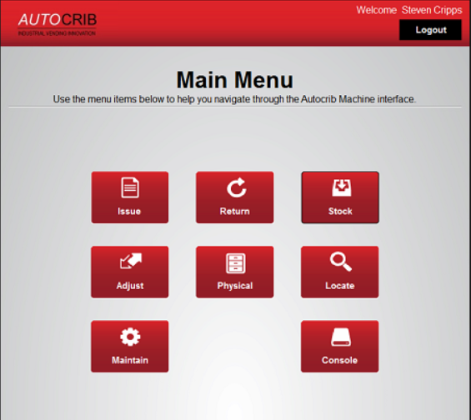
Step #3 – Select “Auto”
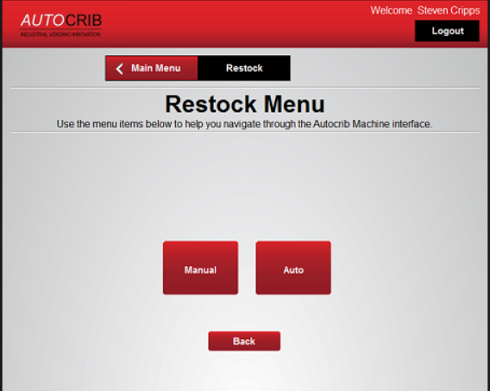

Step #4 – Click on TAG
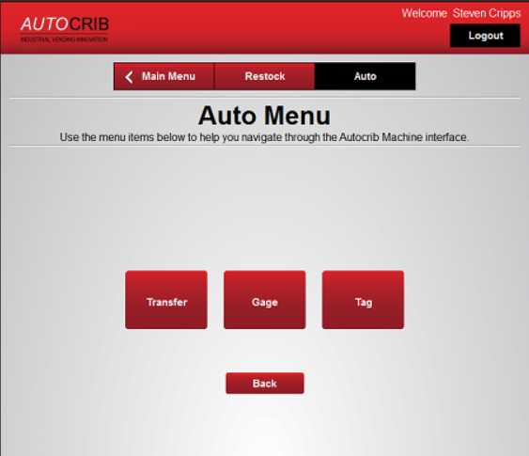
Step #5 – Enter TAG number (this is the PO #)
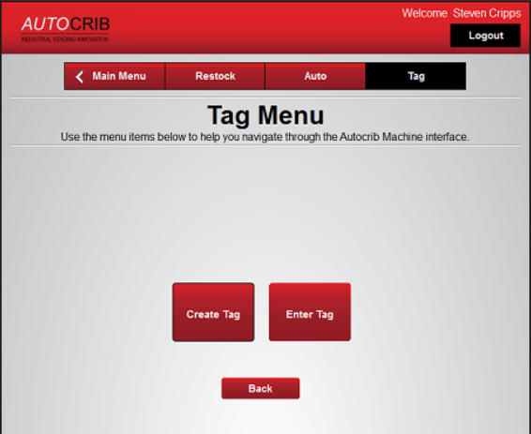
Step #6 – Enter TAG number (this is the PO #)
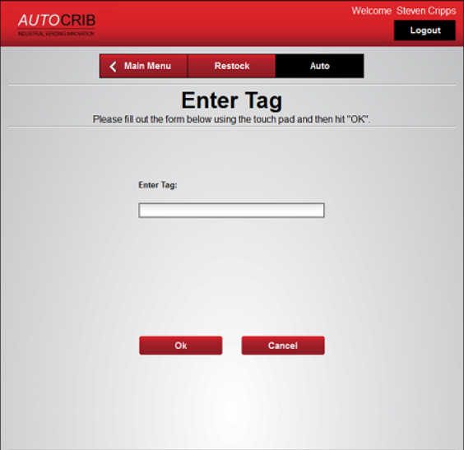
Step #8 – If the “TAG” already exists Create Tag
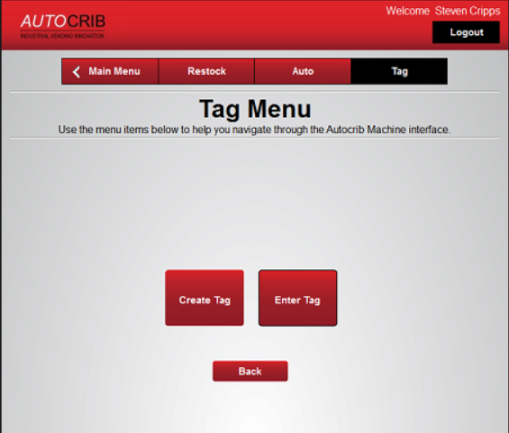
Step #9 – Enter PO Number
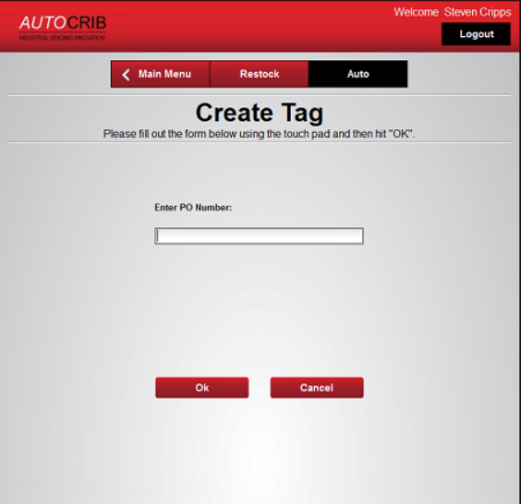
Step #10 – Pop-up screen with “Is Tag Complete”, Click “NO”
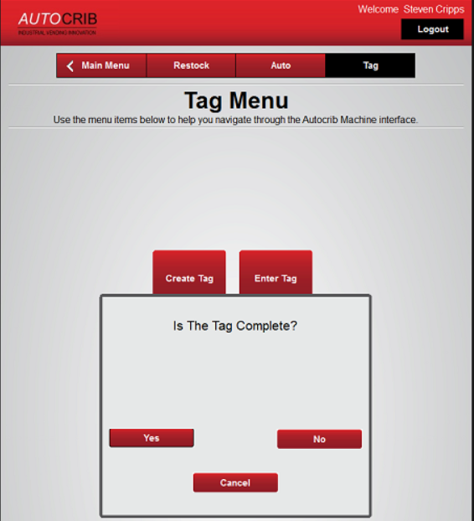
Step #11 – Select “Yes” or “No” – based on if you have stock to receive or not
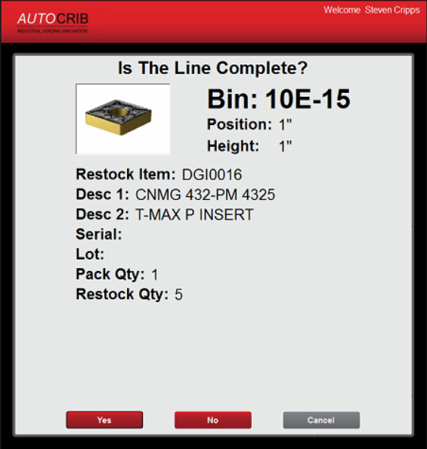

Step #12 – A second window will pop-up asking if you want to receive this bin. You can select no at this point if you hit “yes” by accident, or select “Yes” if this is the bin you want to receive product into
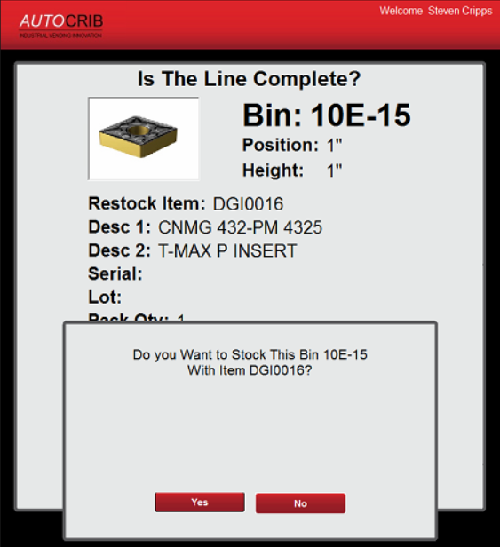
Step #13 – Select Yes
Step #14 – If this is not a “New” item, select NO. If this is a “New” item select Yes
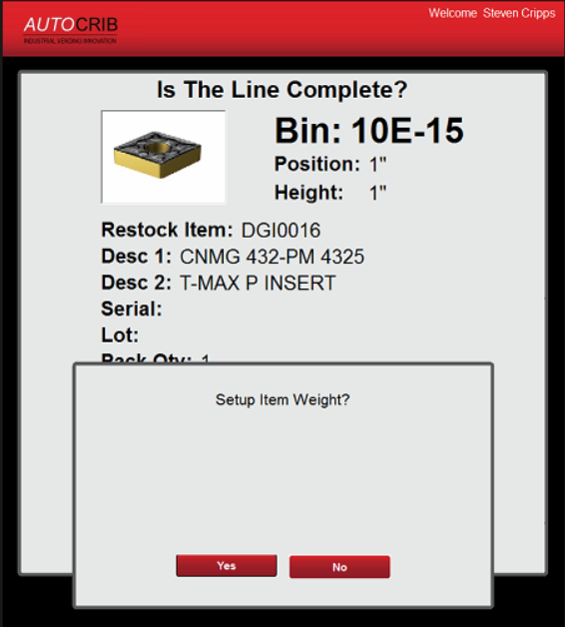
Step #15 – Place all items in the cup and place the cup on the Scale
- Click OK once the cup is on the Scale and not before

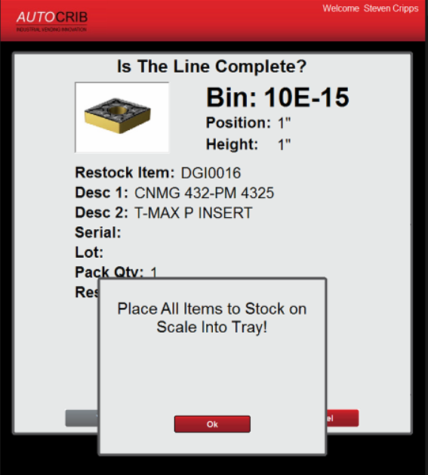

Step #16 – Click on Finish, put the cup back in the Robo and Close the door
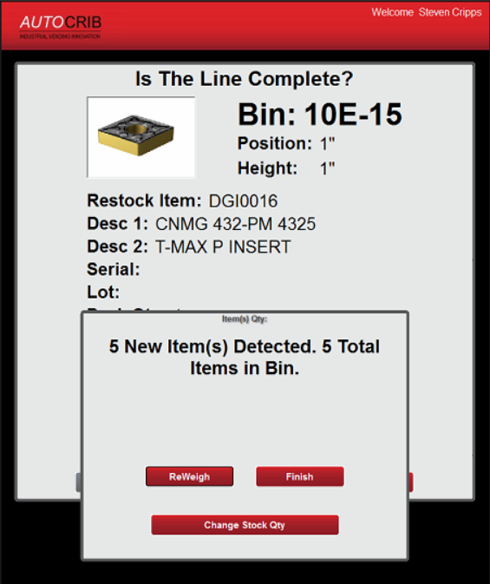
Repeat Steps #1-16 until all Scale items have been received
How to select the appropriate field:
DGI Consigned Inventory = Always received as “On Hand”
DGI Non-Consigned Inventory & Customer Supplied Inventory = Always received as “Burn”

