Tax Assist Rule

- Go to Tax Setup/Tax Assist/Pre-Calculation/Add
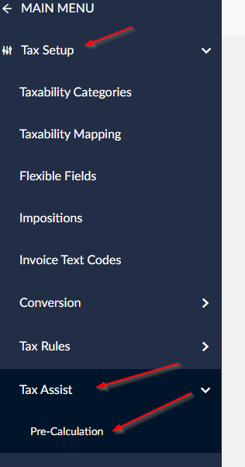

- Type in Name of Tax Assist Rule (this is up to you) and/or a description.
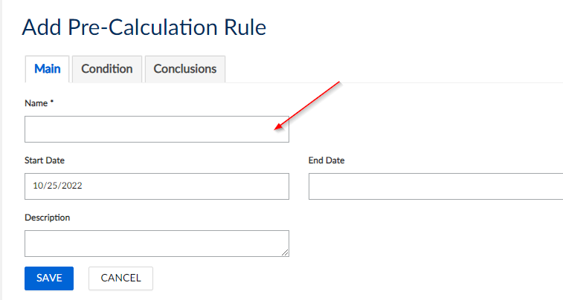

- Go to Condition Tab and place “AND” in the IF field with an “OR” in the second “?”
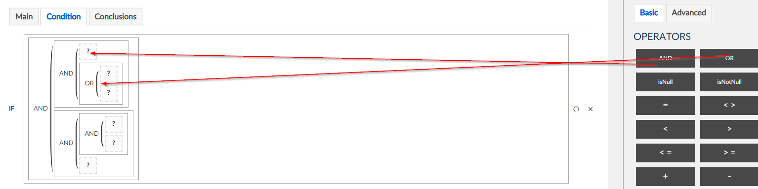

- Inside the “?” place an “=” in each
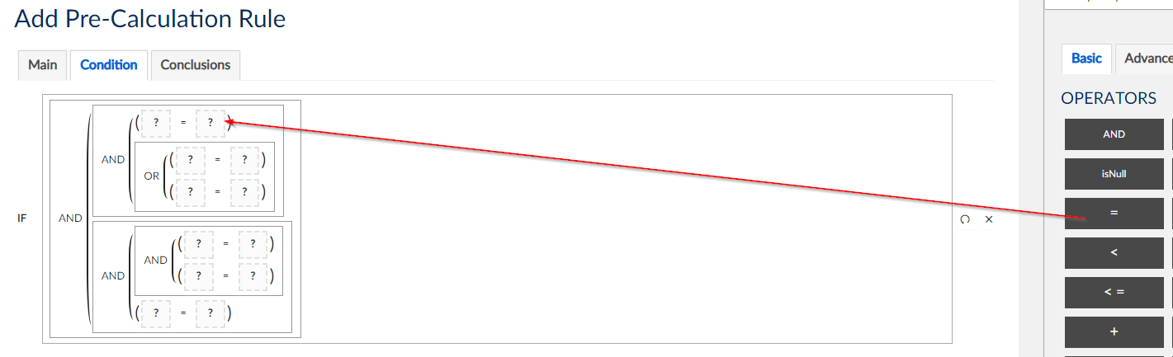

- In each of the 1st “?” box, put the “Taxability Drivers, Codes, Names and Types”
  - In the first field place “Destination.StreetAddress
  - In the second and third field place “Destination.City”
  - In the fourth field place “Destination.SubDivision”
  - In the fifth field place “Destination.MainDivision”
  - In the sixth field place “Destination.PostalCode”
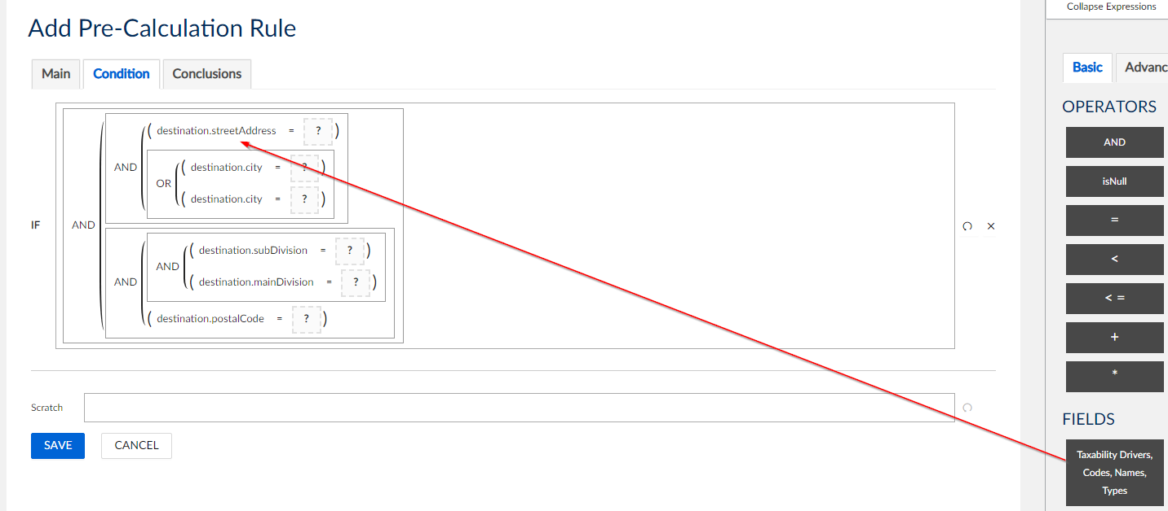

- In the second “?”’s put in “String Values” **values entered here must match what is entered in P21 exactly
  - In the destination.streetAddress field put 480 N PROMEC ST,
  - In the destination.city put GRAND LEDGE and GRANDLEDGE
  - In the destination.subDivision put CLINTON
  - In the destination.mainDivision put MI
  - In the destination.postalCode put 48837 ****only use a five digit zip code

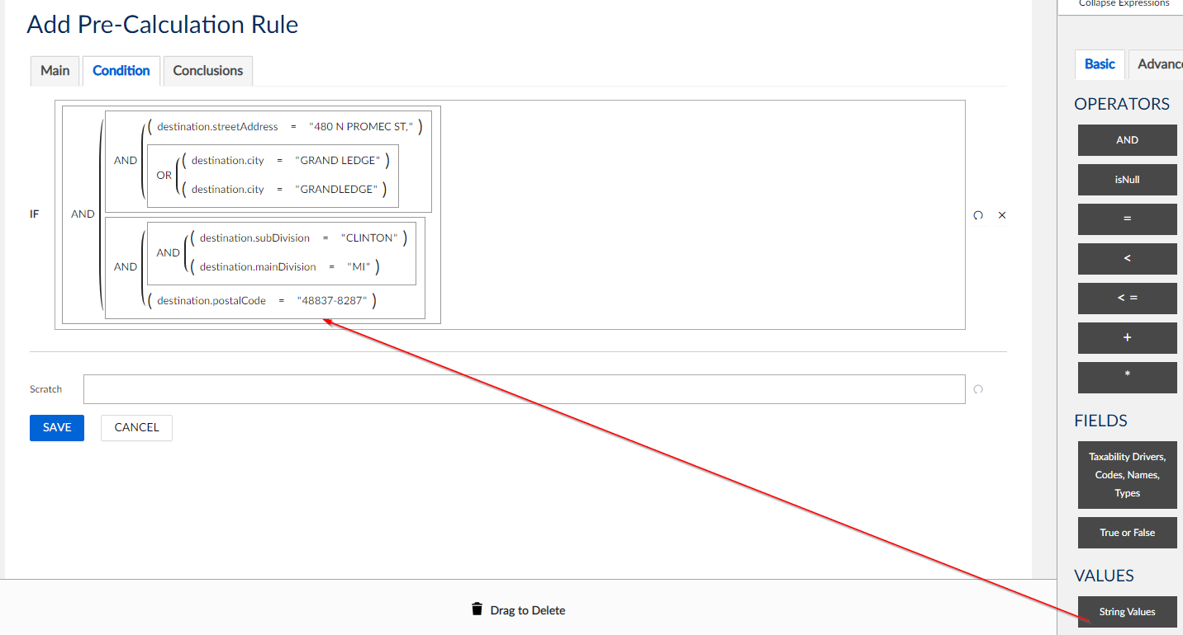

- Go to the Conclusion Tab. In the SET field place “Numbers, Amounts, Rates, Tax Area IDs”
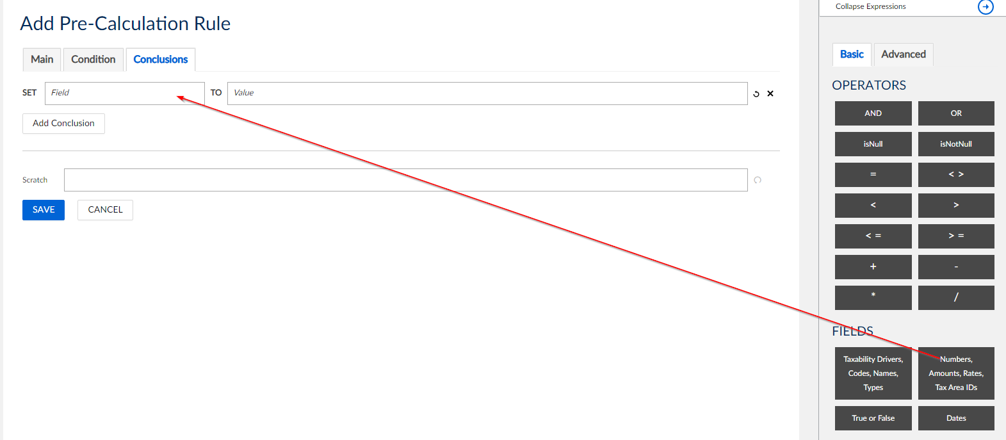

- In the SET field place “destination.taxAreaID”
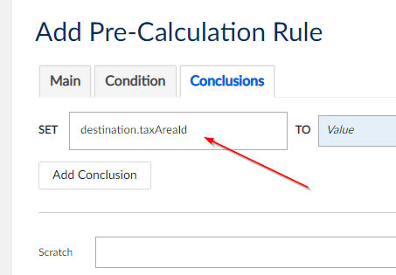

- In the TO field place “Numeric Values”
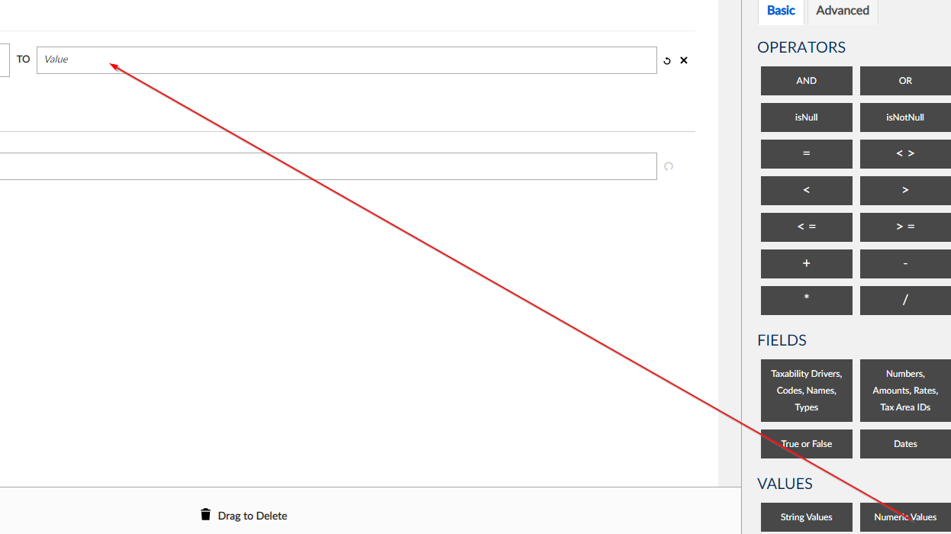

- Put in 230450630 and then click SAVE
