Creating a New Location in P21

Procedure

Document Number: Revision #:
Document Owner: Date Last Updated:
Primary Author: Status: Proposed

General Description

Description / Scope: This process will outline how to create a new consignment location

Who Performs/
Responsibility: IT

When to Perform: When a consignment location is required

Requirements

Access to Address Maintenance, Location Maintenance, Item Default Maintenance

Overview of Steps

- Location set up in Address Maintenance
- Enter location settings in Location Maintenance
- Enter item default settings in Item Default Maintenance
- Set up Transfer Days Maintenance

Detailed Steps

- Canada branches start with 30XXX, Canada consignment locations start with 31xxx, US branch locations start with 40XXX and US consignment locations start with 41XXX. Locate the next available number in Location Maintenance and undelete it in Address Maintenance. Enter the Address and contact information and save.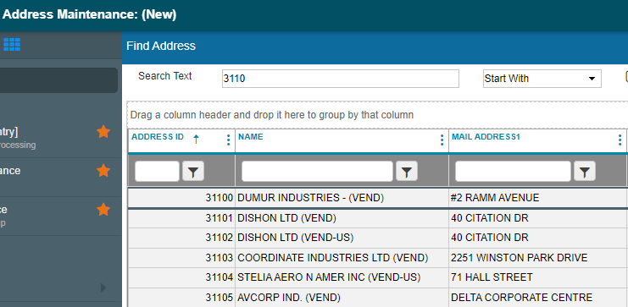

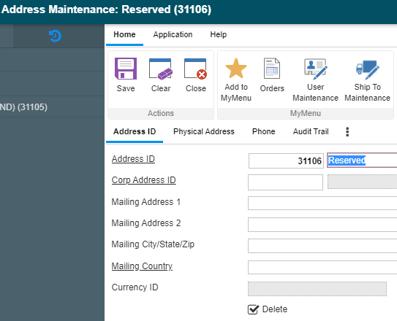

- In Location Maintenance enter the new Address ID as the Location ID. If a consignment, add the branch ID linked to the customer account.
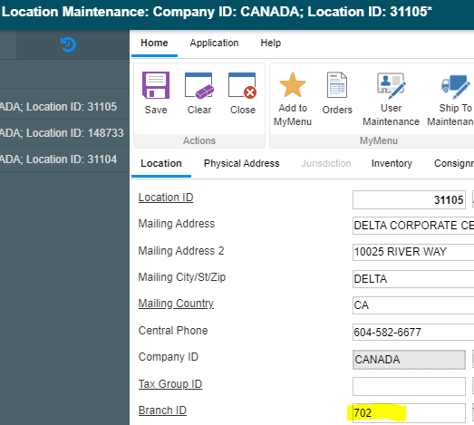
- Copy address in Physical Address tab
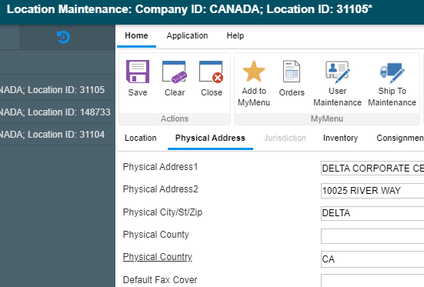

- In the Inventory tab Require Lot/Bin Integration and Use System Default should be checked for threshhold periods.
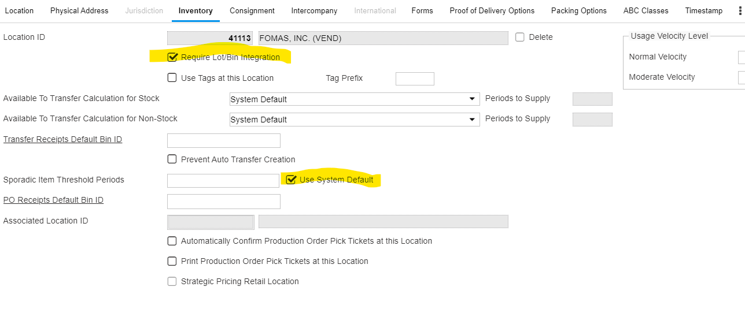
- If a consignment locaiton, in the consignment tab add the assigned customer/ship to and check the Consigned Inventory Location check box. Save
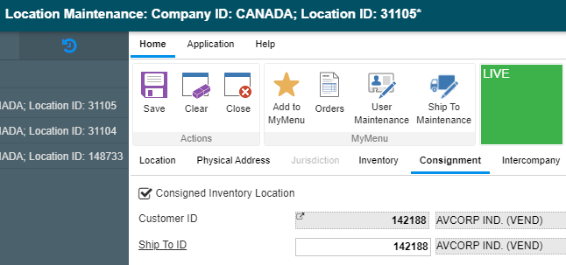

- In the Item Default Maintenance module enter the location ID add DEFAULT for the discount groups and EA for the pricing/base unit. The tax group ID is CAN for Canada, leave blank for the US. Product Group for the US and Canada is DEFAULT. Uncheck Track Lots and Track Bins. For consignment locations uncheck the Buy box on the bottom right.
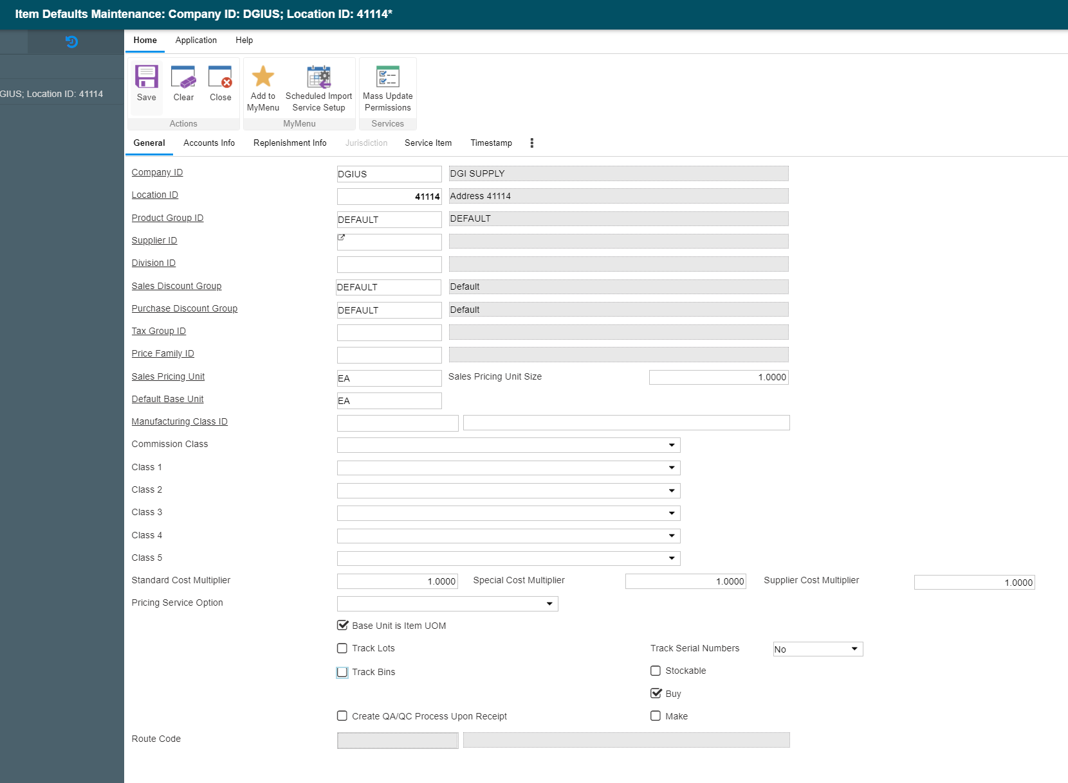

- In the Accounts Info tab the account numbers are provided by the Accounting Department. Each Account Number contains Designator suffix for the Branch ID.
- Uncheck Track Bins.
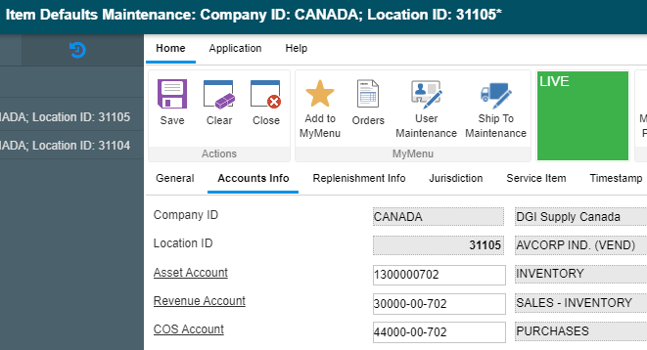

- On the Replenishment Info tab enter the Replenishment Location and save.
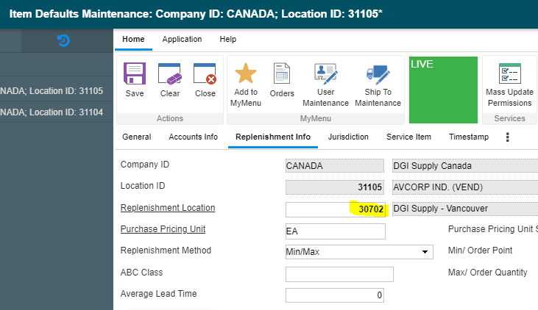
- Go to Transfer Days Maintenance via Inventory Band->Inventory Management->System->Transfer Days Maintenance.
- Input Source Location ID – Branch Location(s) associated with Consignment Customer.
- Input Destination Location ID – Consignment Customer Location from Location Maintenance.
- Confirm that the “Create Order Based Transfers” checkbox is checked.
- Check the “Create Transfer from OE” checkbox.

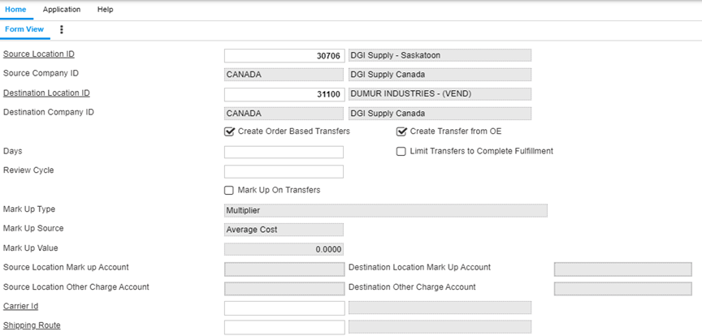

- Click Save.

Note ---You will also need to create the reverse – from the Consignment Location to the Source Location in case products need to be returned. Continue with step 7.

- Input Source Location ID – Consignment Customer Location.
- Input Destination Location ID – Branch Location(s) associated with Consignment Customer.
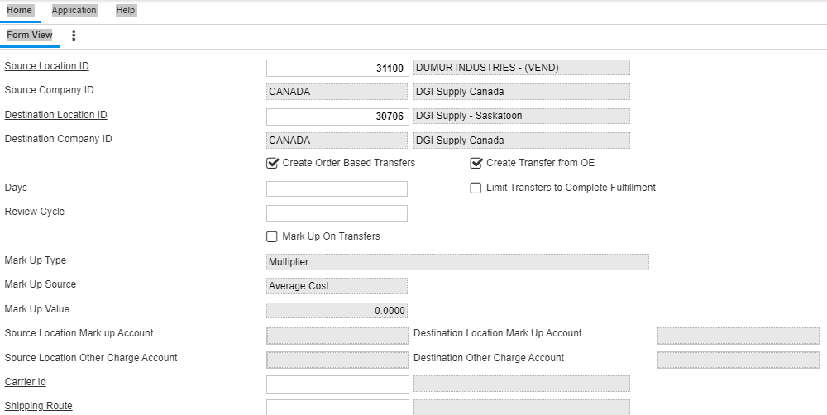

- Click Save.

