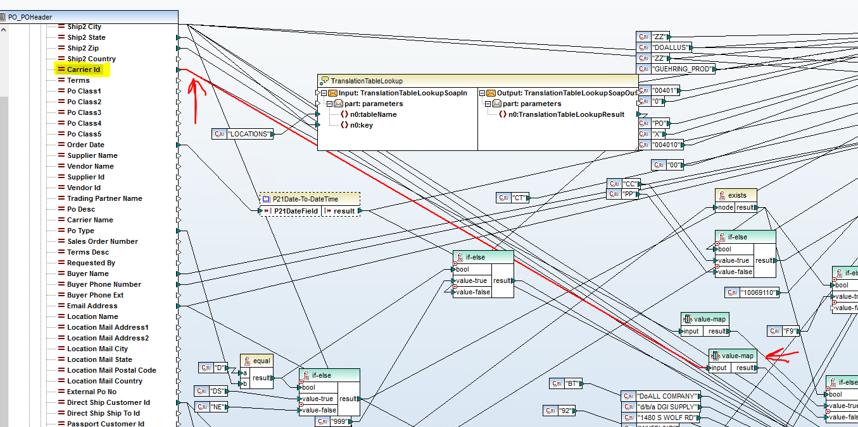

To change the mapping of the values from the 3 digit to 2 character, on the left hand panel, click on “Carrier Id”. Just to the right, click on the line, which will change color to red. See above.

At the other end, is a “Value Map”. See arrow pointing to it. RMB on the Value Map, then click properties. We want to change the 141, 143 codes to the codes according to the chart below. In addition, we want to add a new mapping for code 100010 to WE.
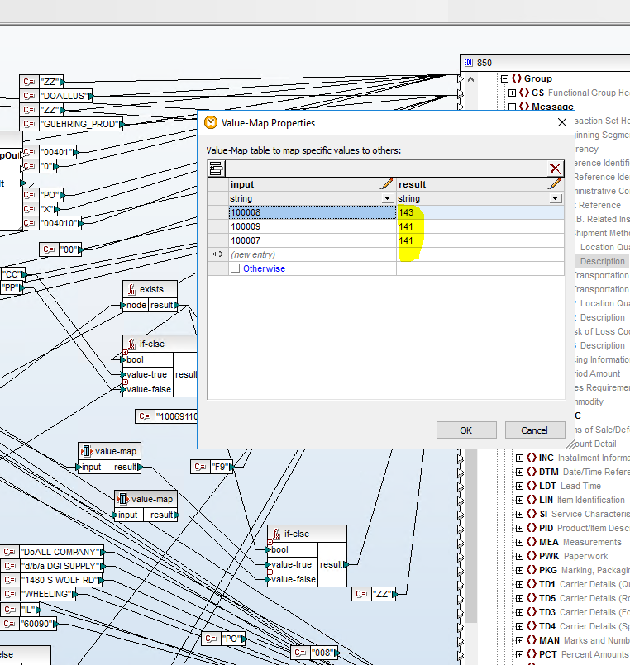

The screen should look like the following after the update:

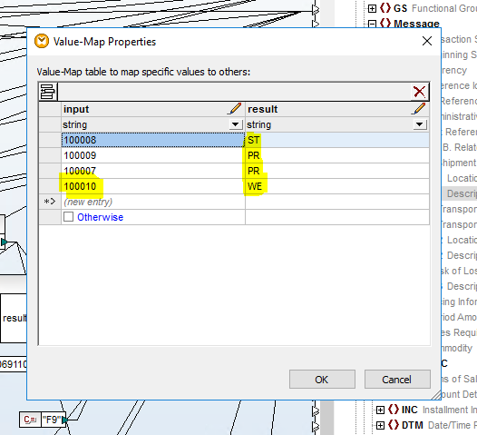

Mapping info provided by Sandvik:
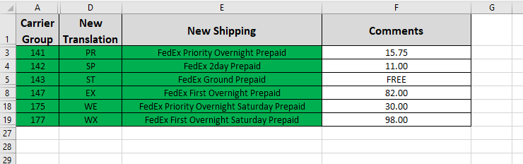

DGI US Carrier Codes
100005 | FedEx 2day
100006 | FedEx Express Saver
100007 | FEDEX FREIGHT PRIORITY
100008 | FedEx Ground
100009 | FedEx Priority Overnight
100010 | FedEx Priority Saturday Delivery
100011 | FedEx Standard Overnight

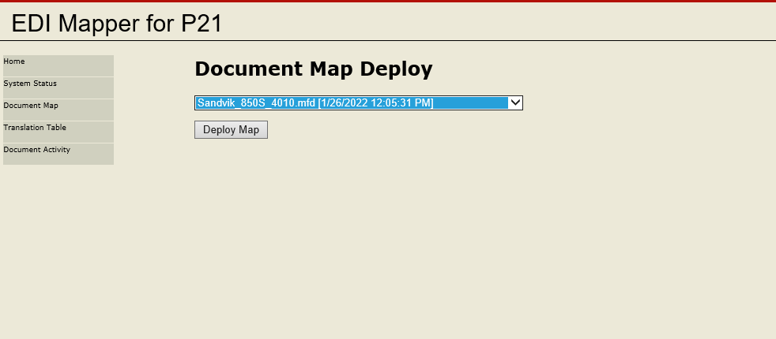

Save the map, then redeploy.

