SOE CONFIGURATION APPLICATION

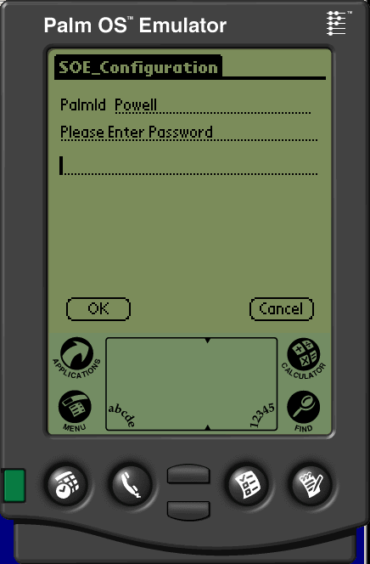

SOE Configuration is a one time application run to setup how the SOE application will behave.

The first prompt is the Palm id. This will default to your palm's ID but can be overwritten to the other palms you will be loading. This way you can create one palm database that contains all of the specific settings for all of the palms out in the field and the palm simply reads it's settings from the list. This ensures that you can view all of the setting for each of the palms as well as makes sure there are backups of these settings. The normal course of action is to set up each of the palms using your test palm, running this configuration software. Then hotsync your palm and locate the ADSSOEConfig.pdb file in your palm's Backup folder. Typically that will be c:\Palm\”your PalmId”\Backup\ADSSOEConfig.pdb. Then load that newly backed up copy to each of your palms in the field using the Palm install application.

The only other prompt here is the password and it is always “fred” (without the quotes). It can be upper or lower case. This password is not a big secret but is used to keep your end user from messing around with the settings and inadvertently breaking their setup.

There are many options and the definitions to each follows:

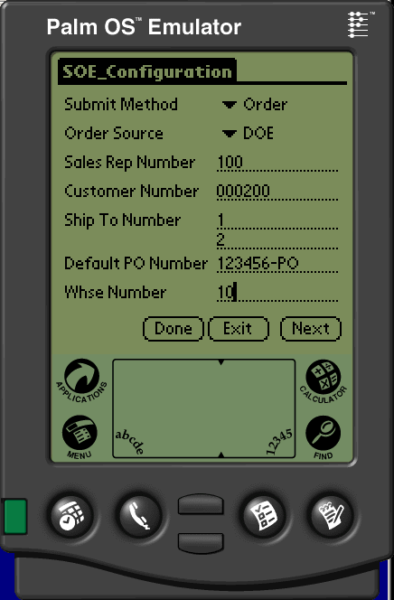

Submit Method: Type of order to create, the options are Order, Quote, Crib Usage, Crib Physical and Web Cart. Order is the standard and will create a normal sales order on ADS. Quote creates an ADS quote. Crib Usage create a crib style sales order. Crib Physical creates a crib style physical count of the stock in the crib and the ADS software will create a replenishment order and transfer. Webcart is a new feature not yet implemented. It will create a cart in the VIA system so that each order will have its own via order and can be manipulated in the VIA software before converting to a sales order.

Contact Prelude before using any but Order to make sure that the ADS software has the changes in place to make use of this flag.

Order Source: DOE or Web, used as a source code for the DOE software on the ADS system. DOE is normal and no real reason to make it Web except possibly for the new Web Cart submit method.

Sales Rep Number, Customer Number, ShipTo Number, Default PO Number and Warehouse Number are defaults. If they are entered then those values will be used in SOE as defaults. These are typically used when you hand the device to your end user. You want to setup the pertinent data so that your customer does not have to keep entering data that is not intuitively obvious to them (like your customer#).

Shipto used to be a single value but now allows multiple shiptos to be entered and if they are entered then you will see a list of available shiptos from SOE.

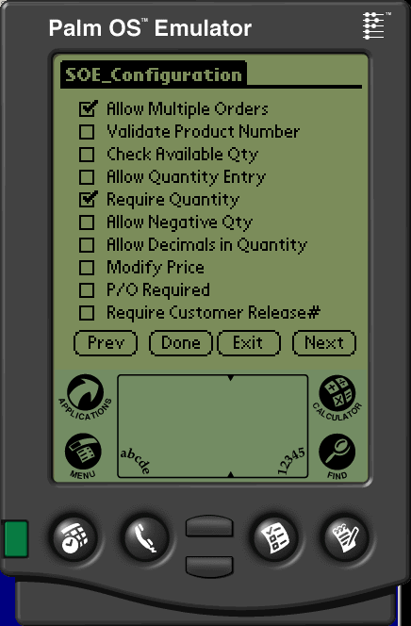

Primary flags defining the way the SOE application behaves.

Allow Multiple Orders: If checked then you may enter multiple sales orders. If unchecked then the order# becomes the customer# and is designed to only allow 1 sales order from 1 customer at a time. So that as the customer scans in products, they all go into 1 sales order that gets transmitted to your when they hotsync. After the hotsync, the device is wiped clean and the next product scan starts a new order.

Validate Product Number: If you have the product file uploaded to the device then this flag decides if you validate against it or allow any data to be entered as a product#. There is a flag on page 4 of this application that allows you to validate and choose whether you want to accept the “bad” product#. This is used for times when you might need to enter a product you are going to carry but is not in the device’s database yet. ‘*’ and non-stock products are also a good reason for this option.

Check Available Qty: If you enter a quantity over the amount considered available then it will warn you and allow you to back out of that entry.

Allow Quantity Entry: If checked then the next prompt will be the QTY field otherwise it is assumed that either the part# scanned has the re-order qty built into it (as some cribs do) or the order quantity is defined somewhere in your ADS DOE system when building the order in the ADS system (like using the default selling qty)

Require QTY: Similar to the one above. You might scan some labels that have qty embedded in it and others as standard part# bar codes. This option allows you to have the mix. Unchecked means that you do not have to enter the qty. If checked then every line item must have a qty entered as well.

Allow Negative QTY: Checked allows credit memo entry.

Allow Decimals In Quantity: If checked you can enter quantities that contain decimals. If this is unchecked (the recommended setting) then PALM will still allow you to enter a decimal but when you go to add the data, it will wipe out the quantity data field and re-prompt for quantity.

Modify Price: Allows you to override the price. NOTE: if you override the price it will be overridden in ADS EVEN IF IT IS A ZERO PRICE! It is highly recommended that this is NOT checked but there are situations that the sales rep has the option to change the price so this option exists.

P/O Required: Just like in ADS is a P/O number required for this order. If checked, then the Application will put the cursor on the Customer P/O# prompt and not close out until one is entered.

Require Customer Release#: Similar to the P/O Required, if checked then the Additional prompt screen will automatically popup and the cursor will move to this field for input. Since Customer Release# is one of the lookup options in ADS Sales Order Inquiry, this is a useful place for the customer to put data to help locate their order after it gets processed.

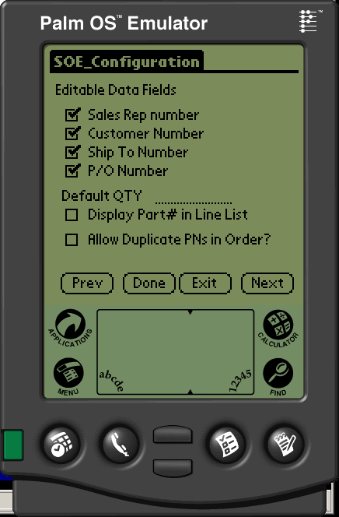

These prompts are used in conjunction with page#1’s fields. They decide if you are allowed to edit it and/or therefore modify it.
A good example of this is that you might have a customer with 2 ship-tos. You would uncheck the Sales Rep#, the Customer# but allow the ship-to numbers to be changed.

Default QTY will put this number in as the default Qty when you are in Line entry mode. Leaving this blank will not enter any number. If you have a product file loaded then we use the default selling quantity from that file and not this field.

If you have the Product file loaded on the Palm and you want the part#, rather than the product description show up in the line item detail window, then check the “Display Part# in Line List” box

If you check the “Allow Duplicate PNs in Order” then it will silently allow duplicates. If unchecked, then it will compare against the previous 10 entered items and if it sees you are trying to enter a duplicate part# you will get a warning with the option to add it anyway.

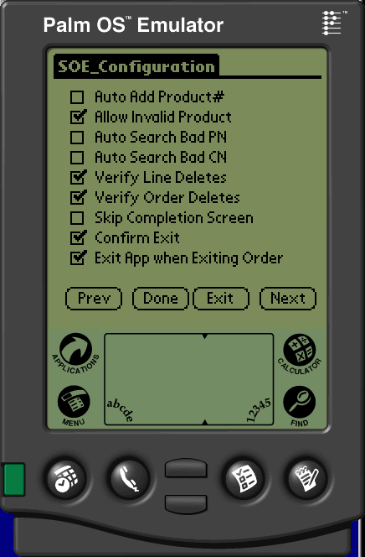

Auto Add Product#: If checked then the application will not prompt for Qty, but rather automatically add the product to the list and move to the next part# prompt. Inputting the Default QTY from the previous screen is applicable.

Allow Invalid Product: Discussed earlier. Allows you to type in a product that might not be in the standard database of products. Only used if you are keeping the Product database on the handheld.

Auto Search Bad PN and Auto Search Bad CN: Same functionality, if you type in a bad customer# or products# in the appropriate prompts, if checked, it will automatically assume you typed in a keyword and go straight to the search window and start a search. Again this assumes you have the proper database loaded on your handheld.

Verify Line Deletes and Verify Order Deletes: Exactly what it sounds like, It will bring up an “Are you Sure?” type message when deleting a line item or the whole order to help prevent you from accidentally deleting something.

Skip Completion Screen: If checked, then the close out screen is not presented when you tap the Done button from the Line Item entry screen. Instead the Done button of the Line Item Screen acts as if it is the Done button of the Completion screen. Note that if you have any prompts required (like the Customer P/O) then it will move to the appropriate screen regardless of this setting.

Confirm Exit: When you click the very last Done button to get out of the order, this will bring up an additional “Are you Sure?” kind of message to make sure you did not accidentally hit the done button.

Exit App when Exiting Order: If checked then when you hit the Done button, it will save the order and exit. Otherwise it will save the order and move the cursor back to the header at the order# prompt to start a new order.

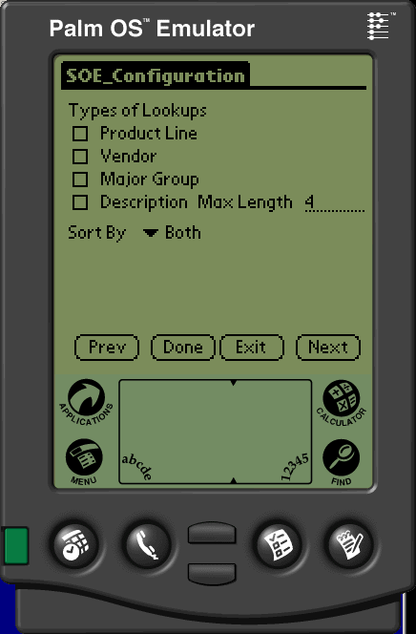

These lookups have not yet been implemented. Because of the tremendous overhead we are waiting for a compelling reason to create these lookups.

Types of additional lookups. By defining multiple methods of product lookup we can shorten a product lookup at the expense of memory size. For example if you are comfortable with product lines and choose a product’s product line then the resulting set of products to search through will be greatly reduced. We can created these cross references for Product Line, Vendor Number or Major Group.

We also have the capability to breakup the product descriptions in certain size.
For example if you set the cut off at 4 characters as shown above then the cross reference for a product with a description of “1-1/4 in stainless steel bolt” would create a xref entry for each word, as well as STAI for the Stainless and STEE for Steel.

You can see that checking this will GREATLY increase the data size but will speed up the searches. If you enter a max of 0 then only whole words are indexed. If you enter 1, then you will get an xref for every letter in the alphabet, which would not be very useful. 4 is a good size if you choose to use this option.

It is important to keep in mind for all of these options, you are creating a tremendous number of extra data that should not be used if you are using bar coded data. This would only be used if you were manually searching for a product which should be less than 1% of the total data entry function.

It is strongly suggested that you do not use these options unless you truly feel it is worth the extra build time and extra data size needed to create the cross references.
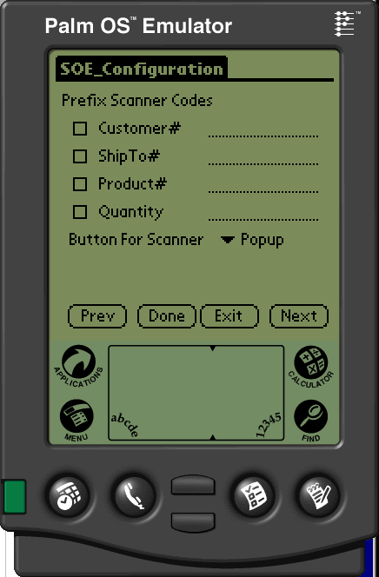

This screen allows your bar codes to have custom prefixes associated with it. This is a data entry validation tool. For example, if you use the letter C in front of the customer number on the bar code so that customer# 123456 is bar coded as C123456 then if your cursor is sitting on the ShipTo# prompt and you scan then customer# bar code it will fail.

Upon scan, we strip off the Prefix scanner code. Verify it against the data field (assuming you have checked the box indicating that you use prefixes. If the Prefixes match, then we enter just the data (no prefix) into the field.

Typically you use single character prefixes, C, S, P, Q but some pre-printed labels might use multiple character prefixes such as Q- or QTY so the configurator allows for multi-character prefixes.

If you manually enter the data you do not need to enter the prefix. It will expect only the real data for all non-scanned data entry. So in the example of the customer# while the scanned data would be C123456 if your bar code is mangled and you have to manually key the customer number in, then you would only type in 123456.

Button for Scanner is to define which button is coded for the scanner. This is for Non-Symbol units with add on scanners.

