NEW Helpdesk Ticketing System
We are pleased to announce the rollout of our new Helpdesk Portal & Online Knowledgebase. Users will be able to obtain self-help information via comprehensive documentation, as well as assisted support with the help of our new helpdesk ticketing portal. This system will allow for a more streamlined process, which will allow for quicker response time for general IT and Building Maintenance inquires. You may access the new helpdesk by navigating your web browser to http://helpdesk.doall.com/

Knowledge Base
On the homepage you will notice the knowledgebase. We will be expanding this collection daily as new processes are documented. Here you can find tutorials on common issues that do not require assistance from IT.

Helpdesk Tickets
All IT or Building Maintenance requests must be submitted in the form of a Ticket. There are three methods of which you can submit a ticket. Please follow the below procedures on how to submit a ticket:

Method One (Preferred Method):
- Navigate to the helpdesk portal at http://helpdesk.doall.com/
- Click on the “New Ticket” button located on the upper right hand side
- Enter in your email address, subject, and brief description of your request
- Select the department and category of which your request pertains to
- Set the priority of your ticket.
- Attach any files you think may be useful (for example: screenshots of error messages)
- Fill out any additional fields below (may vary based on the department and category you selected)
- Click “Submit”. Once submitted a confirmation email will be emailed to you shortly.

Method Two:
- Open Outlook
- Send an email to helpdesk@doall.com
- Please include a detailed message for the request and attach any files that maybe helpful to resolve your issue.
- Once the email is sent it will create a ticket in the new helpdesk portal and reply back with a confirmation email.

Method Three: (Least Preferred)
Dial Extension 13000

Ticket Tracking
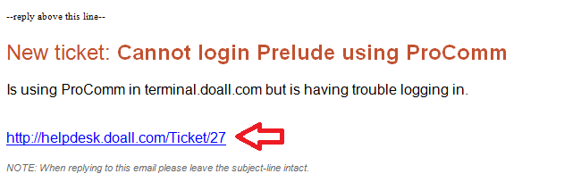
Once your ticket has been submitted you will receive a confirmation email with a link towards the bottom. You may use that link to view your ticket status.

