GoToMeeting Process
- Open a web browser and go to www.gotomeeting.com
- Click on the Sign In button on the top right of the screen

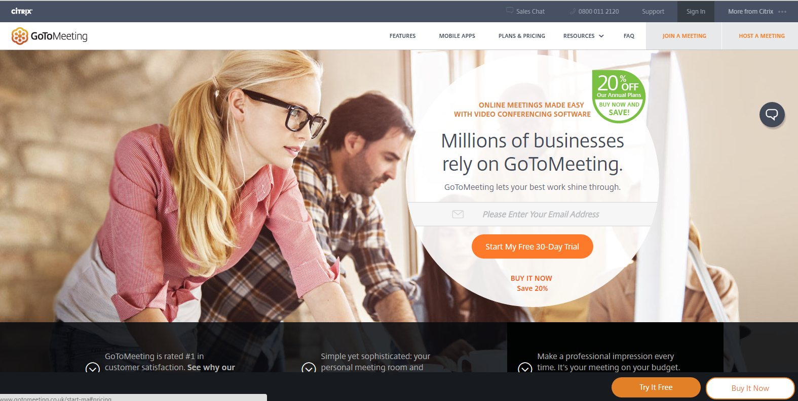

- Enter the username and password

Please request username and password from Human Resources

- You can select 'meet now' if you need to schedule an adhoc meeting. Otherwise, if you are scheduling in advance, select 'schedule a meeting'.
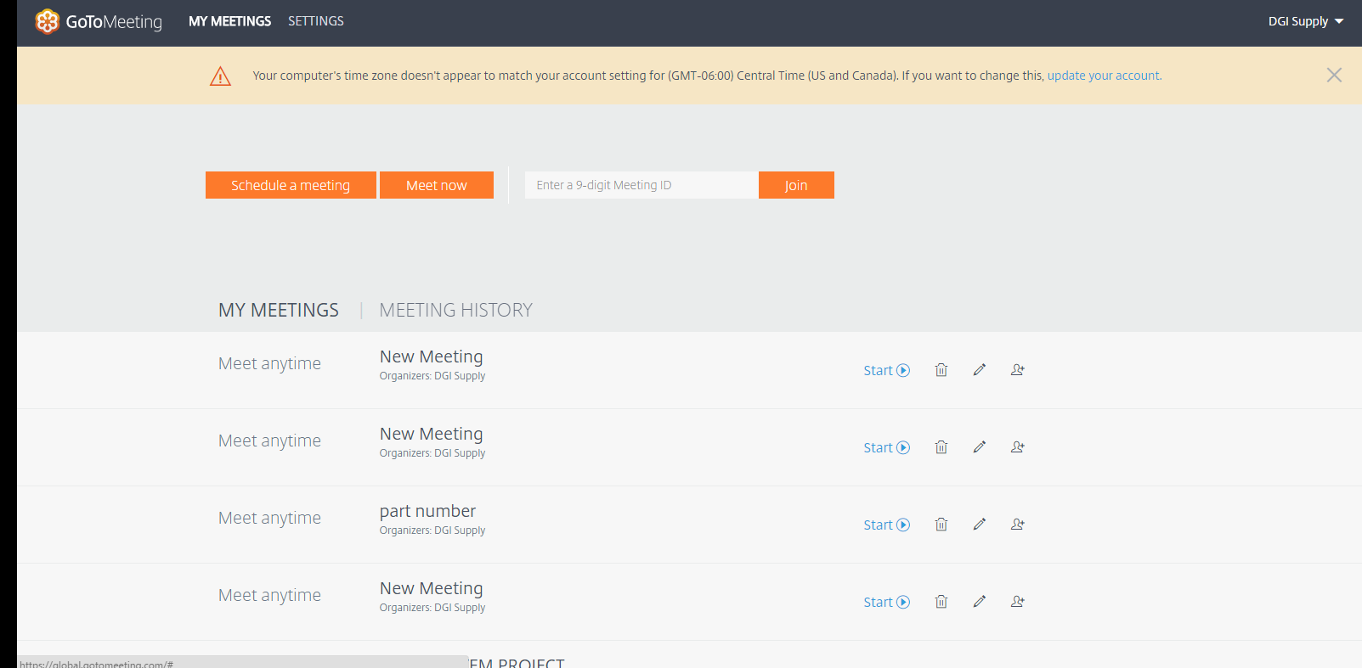
- Selecting Meet Now
  - A meeting will open up immediately. To invite individuals to the meeting, select the 'attendees' box within the meeting, and select 'invite'
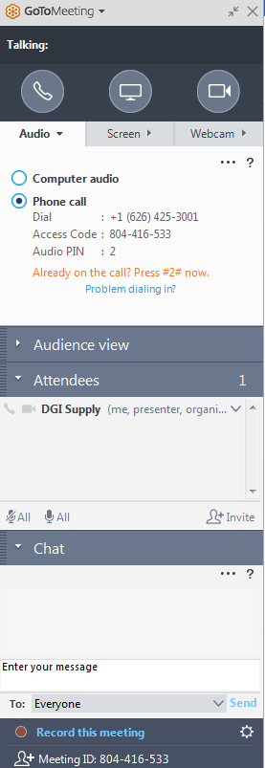

- Selecting Schedule a Meeting
  - Change the 'new meeting' to the name of the meeting
  - Change the date and time. Note that the time zone is default to Central Time (Chicago). Update the time zone before you select save.
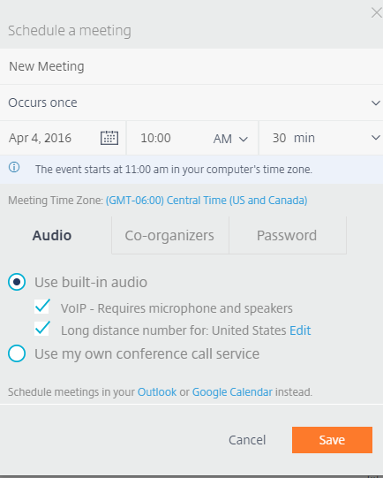
  - Once you select save, the details to send the meeting invite to people appear. Click copy, open an e-mail and send to the meeting attendees.

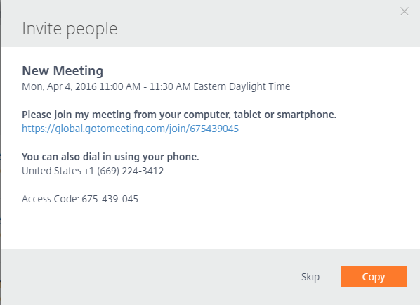
Note - you are able to use either your desk phone, or the gotomeeting phone service, to hold the meeting. You don’t have to use either. If the number of attendees is small (e.g. 2-3) its best to use your desk phone. For larger groups, best to use the gotomeeting phone service.
The gotomeeting phone call in details, access code, and pin are in the box displayed above in the meeting.
Also note that if you are leading a gotomeeting for the first time, you may be prompted to install software. Best to log in a few minutes ahead of time.
Lastly, sometimes the gotomeeting session ends abruptly for all attendees. This can happen because someone inadvertently deleted the meeting in session. Should this happen, use the meet now option and send the invite out to all attendees to immediately resume the meeting.

