On the Canada and Groves EDI servers, P21CATPCXAZ and P21GITPCXAZ2, in the C:\TPCXSPoke\tomcat\conf folder, there is a file name tomcat-users.XML.
The Crowdstrike issue caused this file to be blanked out. The result was tomcat did not allow any tpcx activity, rending the EDI severs unreachable on port 8090.

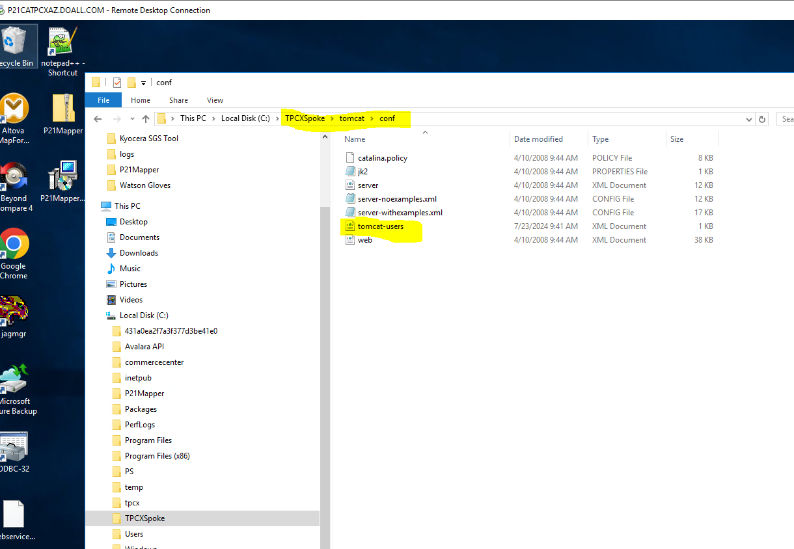

To resolve the issue, the following steps took place:
On the EDI server, stop the following services, Jaguar, Derby and Tomcat.
Epicor provided a template file, which was copy/pasted over in the folder above. Then saved.
The content of the file is as follows:
<?xml version='1.0' encoding='utf-8'?>
<tomcat-users>
<role rolename="tomcat"/>
<role rolename="role1"/>
<user username="tomcat" password="tomcat" roles="tomcat"/>
<user username="role1" password="tomcat" roles="role1"/>
<user username="both" password="tomcat" roles="tomcat,role1"/>
</tomcat-users>

Jaguar, Derby and Tomcat services were restarted.
The system was rebooted.

Upon startup, the tpcx_spokelog file is observed, to ensure activity is taking place.

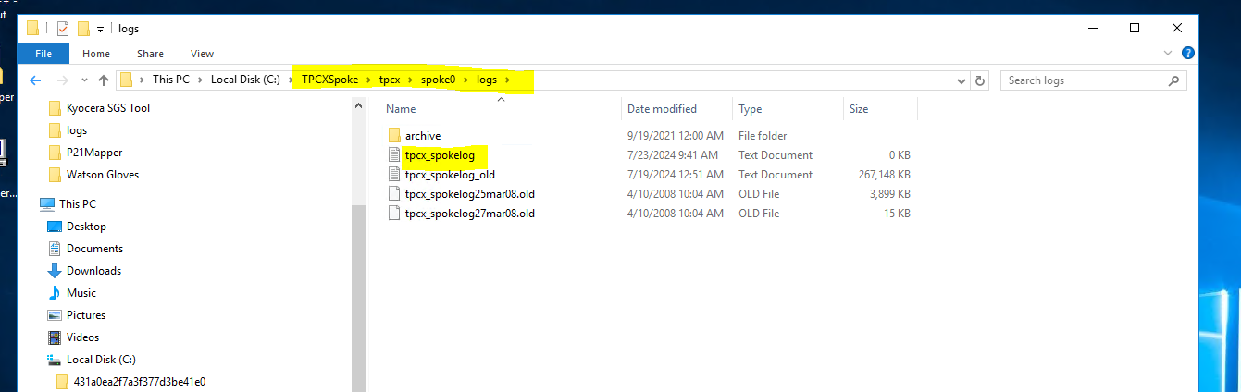

All the files in the inbound and outbound files should have been processed.

