Returns – How to load back into RoboCribs

Step #1 – Log into the Vending Equipment
Step #2 – Select Stock

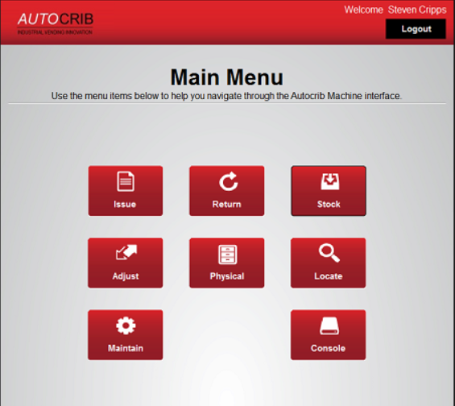

Step #3 – Select Manual

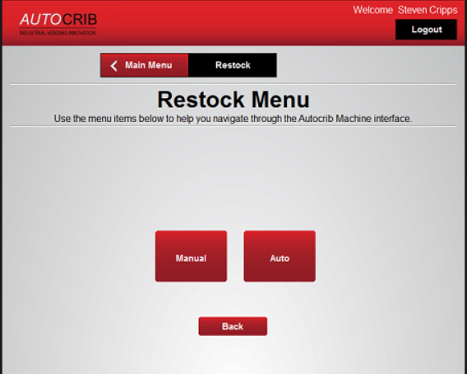

Step #4 – Select Item

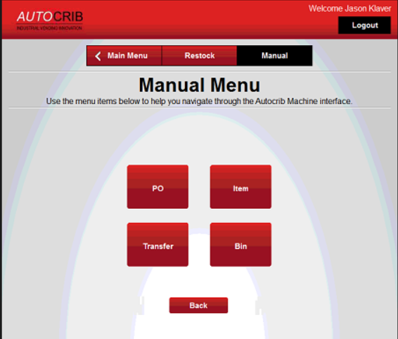

Step #5 – Enter the “Item” into the search field and hit the “Enter” button on the keyboard

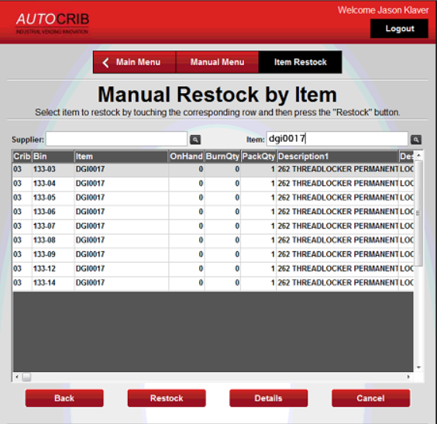

Step #6 – Select one of the items
Step #7 – Select “Restock”

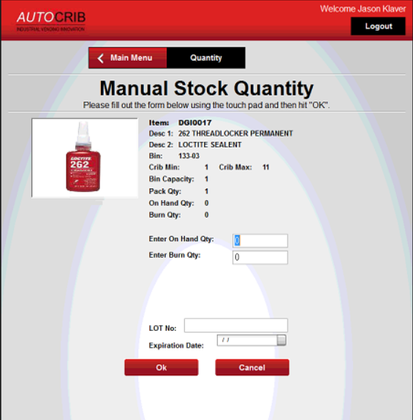

Step #8 – Enter the Qty into the “Burn” field
- If it is “lot controlled” item, make sure information is entered
Step #9 – Select “OK”
Step #10 – Load the item once the door has opened
Step #11 – Close door

Repeat steps #5-11 until all items have been put away

