AutoCrib Stores Receiving

Step #1 – Sign in to AutoCrib Software

Step #2 – Go to Purchasing Module

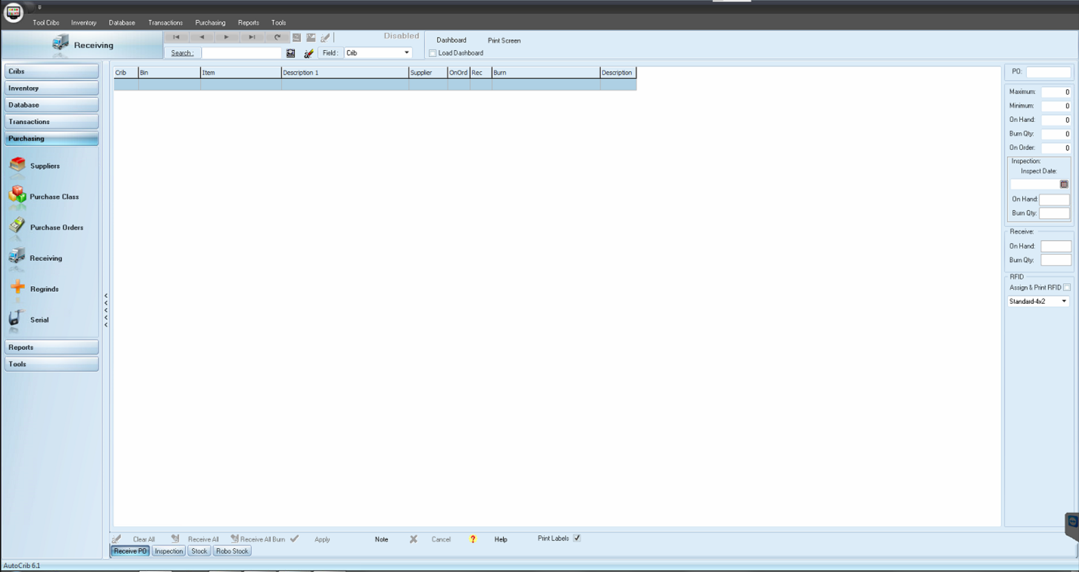

Step #3 – Go to Receiving Function
Step #4 – Go to “Receive PO”
Step #5 – Click in PO area (Green box top right)

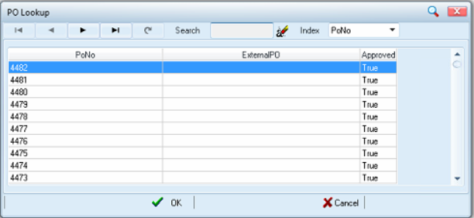

Step #6 – Search for the PO you want to Receive against when the Pop-up window appears

Step #7 – Click Clear All before receiving any items

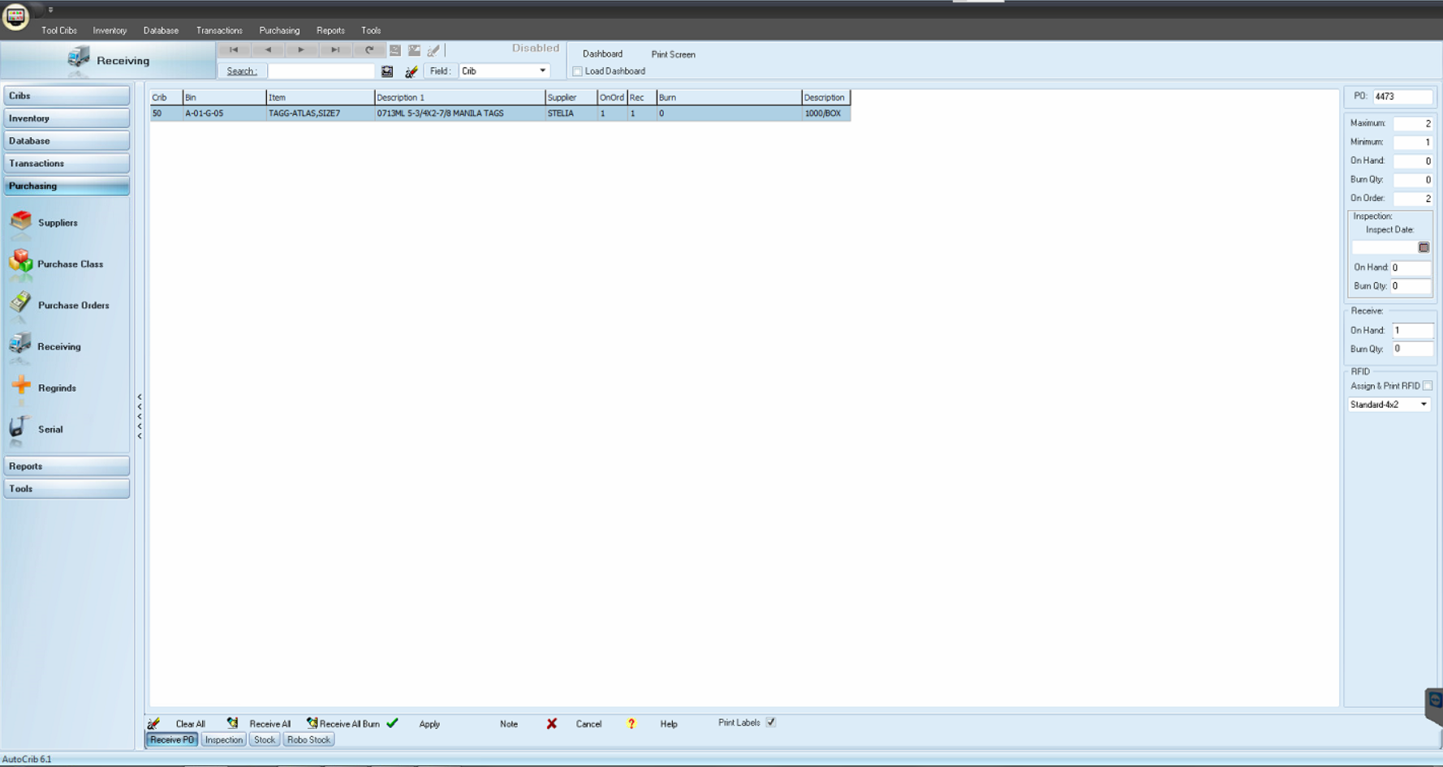

Step #8 – Receive quantity (Make sure you receive into “Receive” and not “Inspection”)
- On Hand is DGI owned inventory
- Burn is Customer owned inventory

Step #9 – If a label is required from AutoCrib check “Print Label”, otherwise leave it unchecked
- If the label is required, make sure the printer has label paper in it before you go to Step #10
Step #10 – Click on Apply

How to select the appropriate field:
DGI Consigned Inventory = Always received as “On Hand”
DGI Non-Consigned Inventory & Customer Supplied Inventory = Always received as “Burn”

