Restocking External Crib

Step #1 – Log into RoboCrib/Locker Software
Step #2 – Select “Stock”
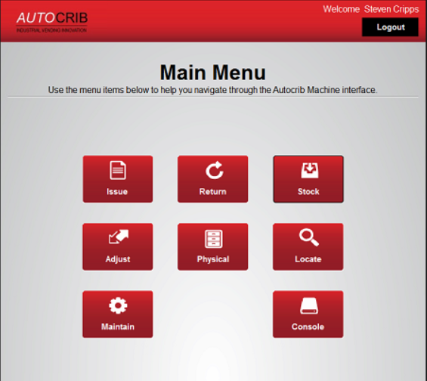
Step #3 – Select “Auto”
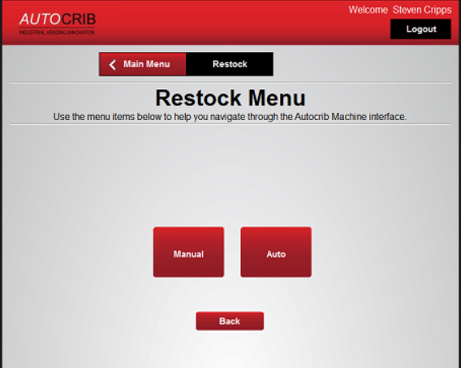

Step #4 – Click on TAG
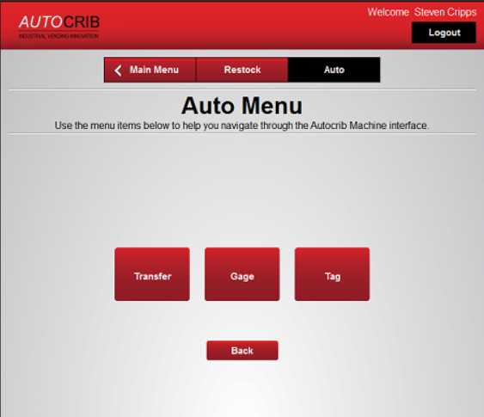
Step #5 – Enter TAG number (this is the PO #)
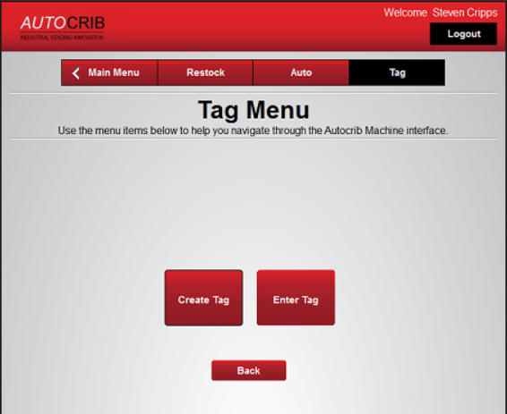
Step #6 – Enter TAG number (this is the PO #)
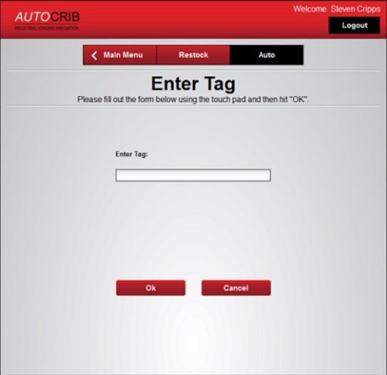
Step #8 – If the “TAG” already exists Create Tag
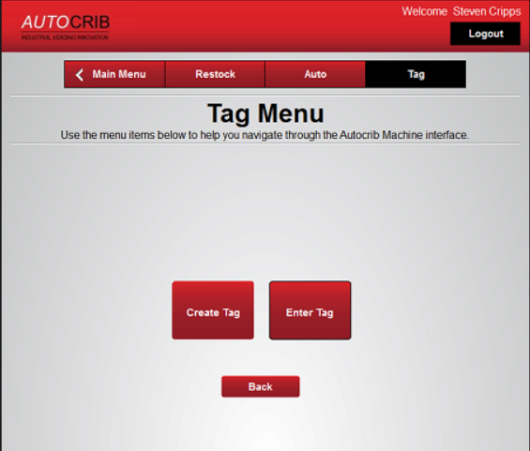
Step #9 – Enter PO Number
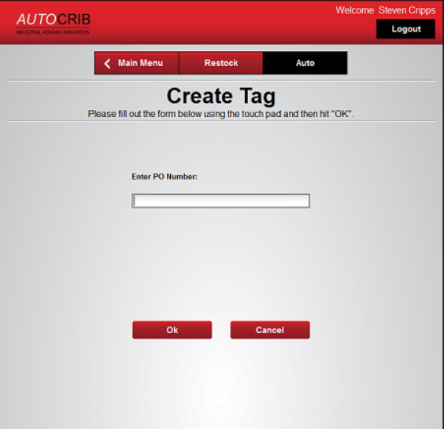

Step #9 – If this is the item you want to stock click “no” to receive the items.
- The items need to be received into “Burn” as it will be billed to the customer and not consigned

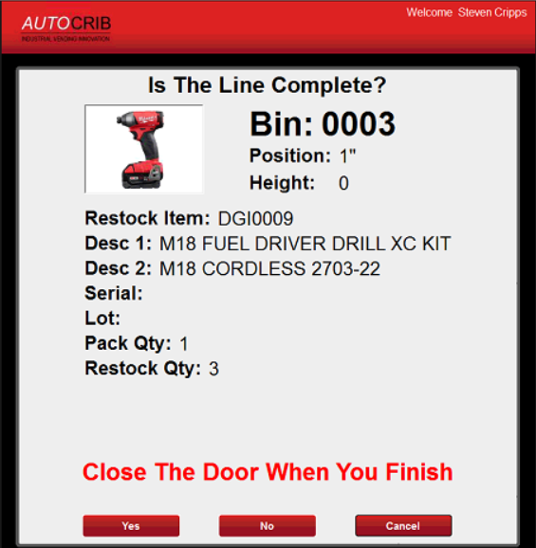

Step #10 – Enter quantity you want to receive on this item, into “Burn”

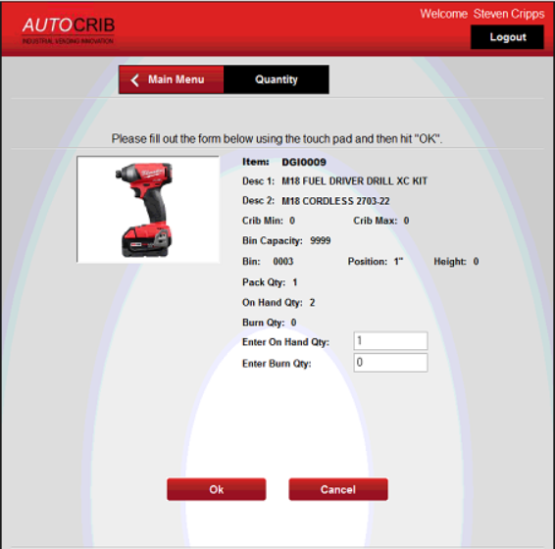

Step #11 – The Key Issue function will appear, to be able to open the External cabinet(s) and put the stock away
- Issue Key

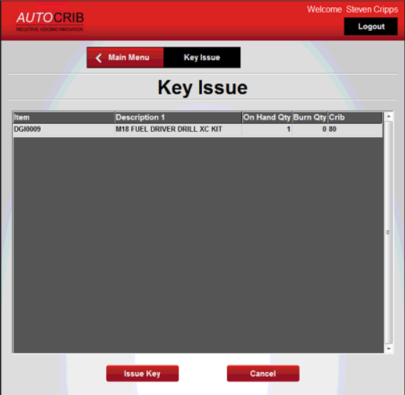

Step #12 – Put stock away
Step #13 – Return Key to RoboCrib
- Click on Return

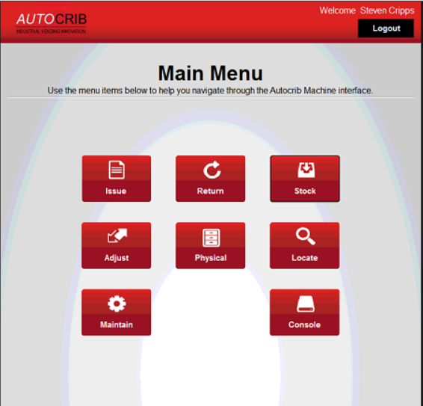

Step #14 – Click Yes to put External Key away

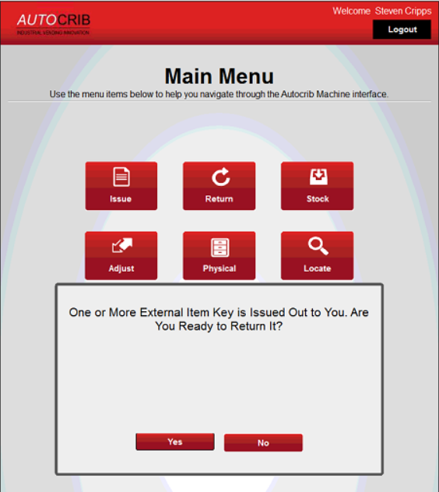

Step #15 – Click on the Key that you want to return

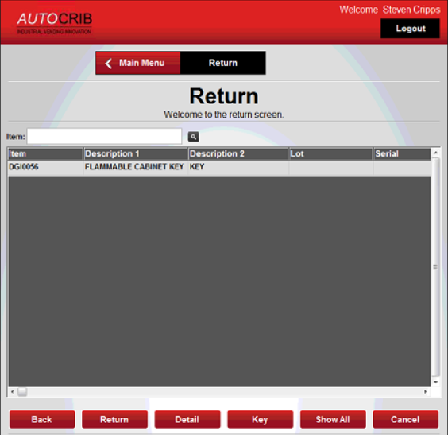

Step #16 – Click on “Return”
Step #17 – Return the Key to the Bin in the Robo and close the door

