Lot Control Receiving

Step #1 – Log into Robo/Locker Software
Step #2 – Select “Stock”
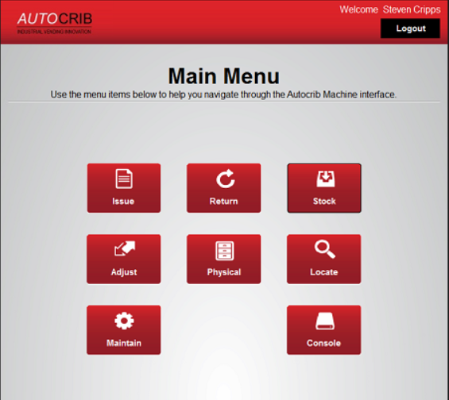
Step #3 – Select “Manual”
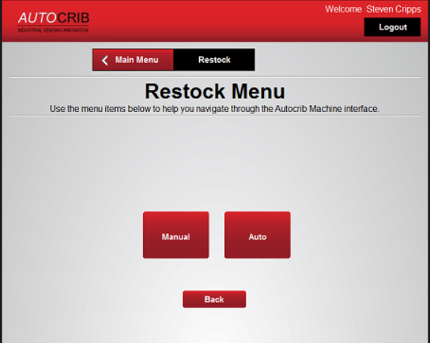

Step #4 – Enter the “PO”
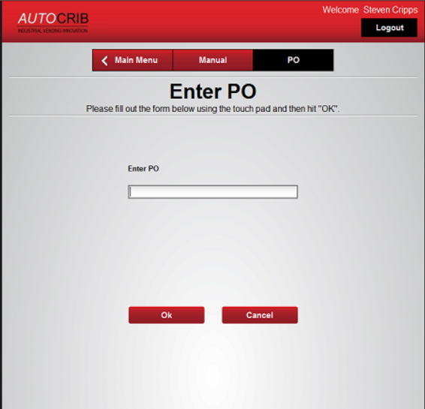
Step #5 – Select the “Item”

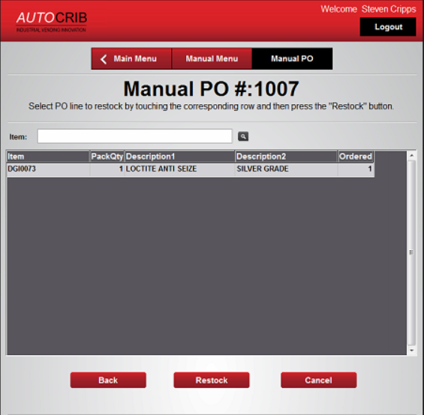

Step #6 – Select “Restock”

Step #7 - Enter Lot “Control No.” and “Expiration Date”

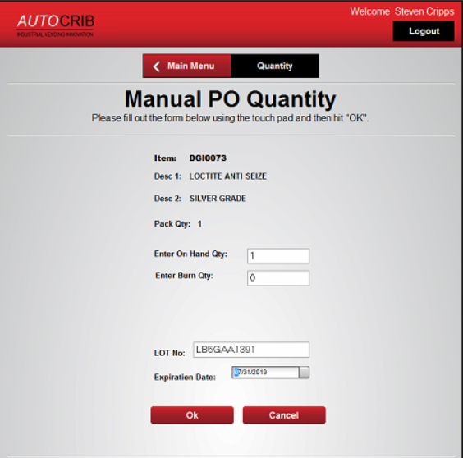

Step #8 – Click “OK” once completed

Step #9 – Stock item in the bin
- All the information you typed in for the Lot Control number will appear on the screen when the door opens, and you put the product in the bin

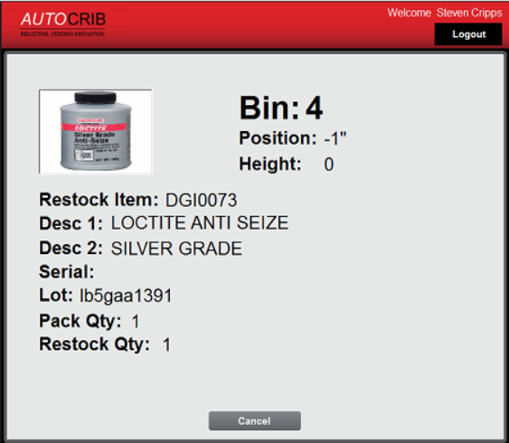

Step #10 – Log Out

