RoboCrib – Receiving (On Hand & Burn)
Manual Receiving Process
Step #1 - Login to the Vending Machine
Step #2 – Select “Stock”
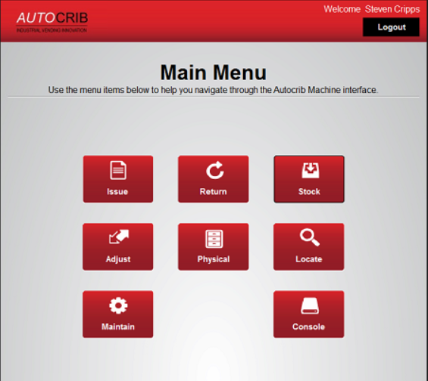
Step #3 – Select “Manual”
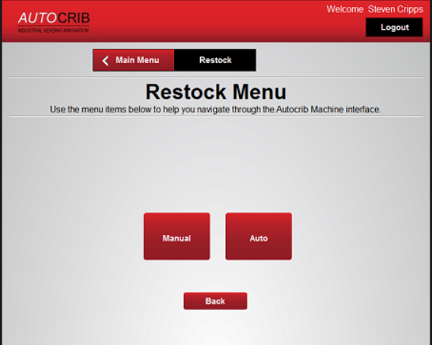

Step #4 – Select “PO”
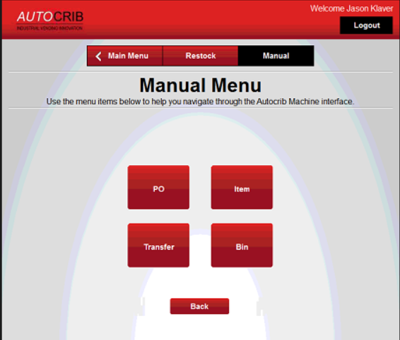
Step #5 – Enter the “PO”
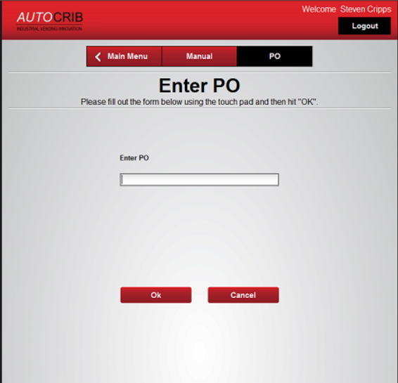
Step #6 – Select the “Item”
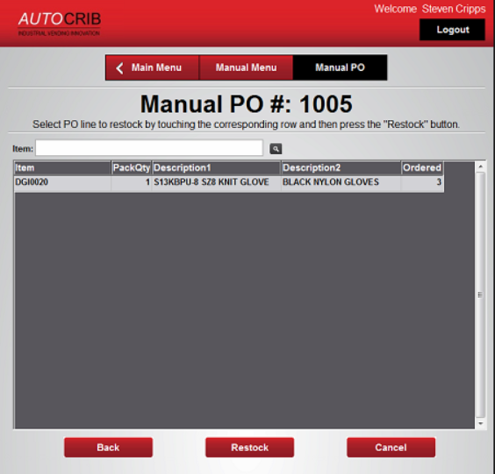
Step #7 – Select “Restock”
Step #8 – Enter in the Quantity to be received in the appropriate field
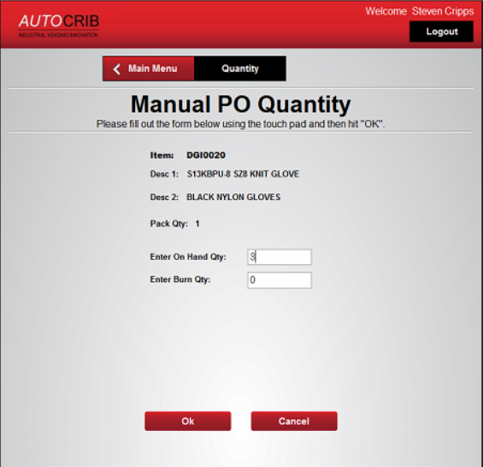
Step #9 – Click OK and load the bins as the machine brings up the bins and opens the doors

How to select the appropriate field:
DGI Consigned Inventory = Always received as “On Hand”
DGI Non-Consigned Inventory & Customer Supplied Inventory = Always received as “Burn”

