CSC Tool’s required to be kept in DGI Vehicles

Tool List:

1 x PICQUIC Screw Driver 1 x Security Screw Driver

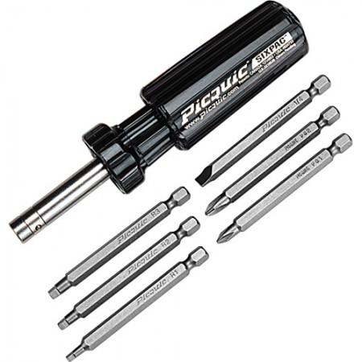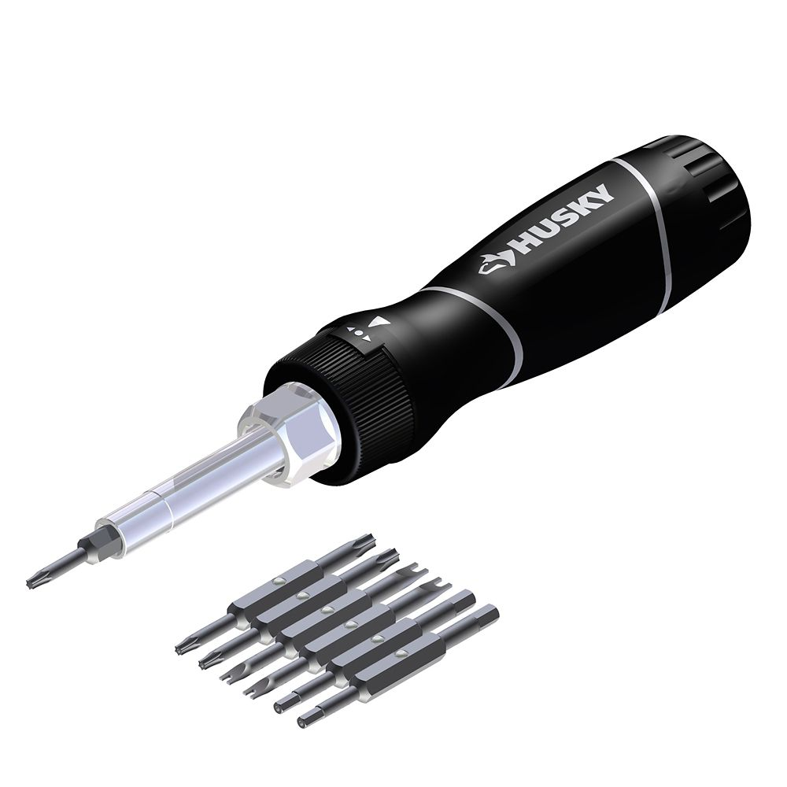

1 x Tool Set – Approx. 200pcs 1 x Plier Set

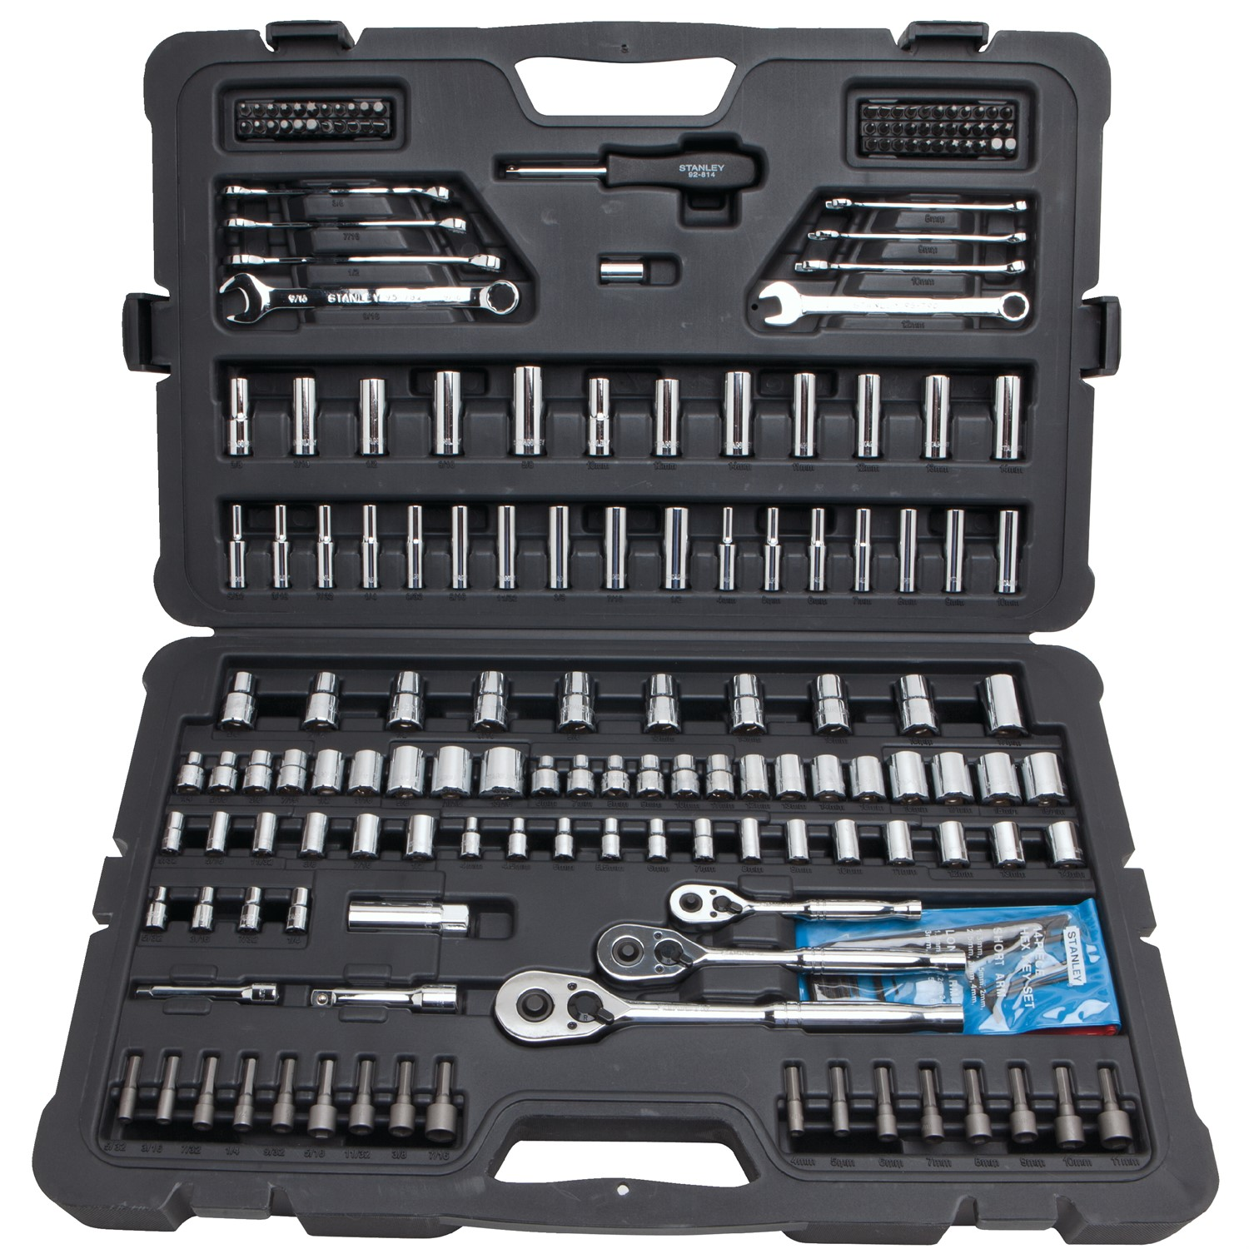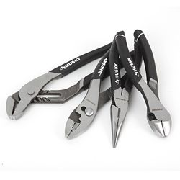

1 x Adjustable Wrench Set 1 x 5/32” Allen Key Socket

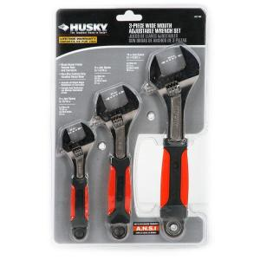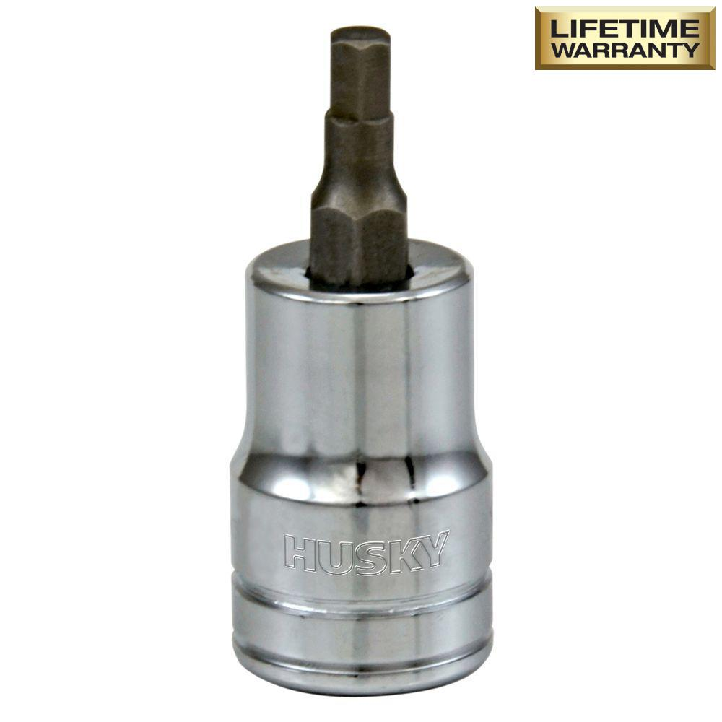

Electronics Required:

1 x Hard Drive Recovery Tool 1 x 16GB (Minimum) Memory Stick
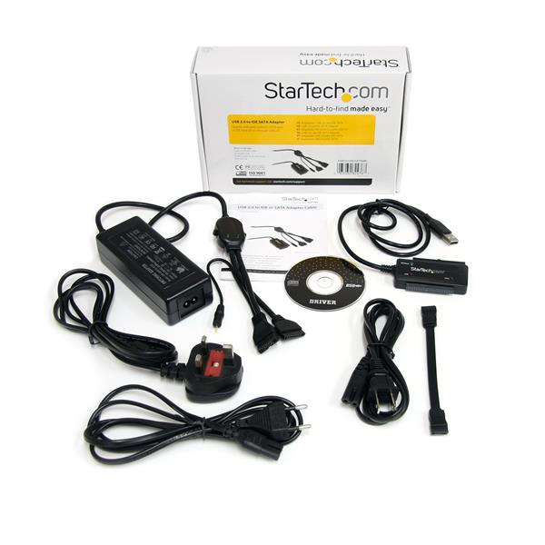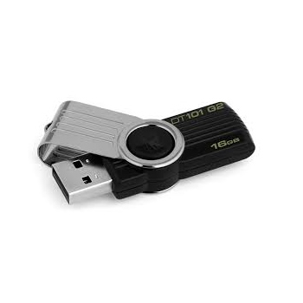
Consumable Products:

1 x 90ml tube Silicone 1 x Roll of Electrical Tape

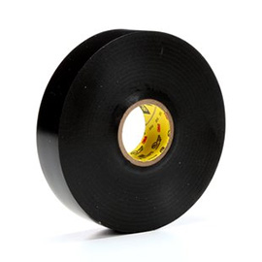

1 x Package of Cable ties 1 x Shop Towel Box

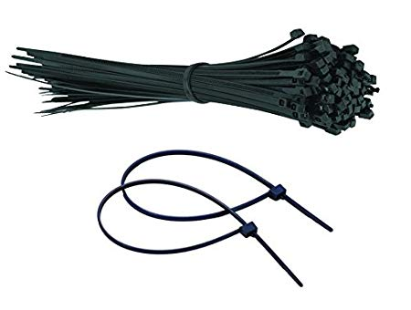

1 x Windex 1 x Electrical Contact Cleaner 1 x Brake Cleaner

Branch Required:

1 X Cordless Drill / Impactor Kit
