Customer Pricing Generator

Document Owner: Mike Rigato Revision #: 1.40
Date Last Updated: 01/19/2022 Status: Final

General Description

Who Performs/Responsibility: Customer Pricing Generator is used to generate customer specific pricing using the Customer Id & Item Id combinations as input.

Responsibility: Pricing Department | Pricing Analysts | Inventory Department | Inventory Specialists
When to Perform: Any time customer specific pricing is needed to be looked up.

Requirements

Access to:

for Canada; \\P21app\P21Shares folder

for USA; \\P21usapp\P21Shares folder

Overview of Steps

- Create an input file
- Place the input file into “Input Folder”
- Retrieve the results file from “Output Folder”

Detailed Steps
- Create an input file
Files to be processed shall meet the following requirements:
- File shall be a Microsoft Excel file with an .xlsx extension (Excel version 2007 or later).
- Any records to be processed must be in the first sheet (or tab) of the Excel file. Sheets beyond the first sheet will be ignored.
- The first row of the spreadsheet will be ignored and can be used for column headers. The actual values of the column headers are irrelevant to the process.
- The first column of the spreadsheet shall contain the P21 ‘Customer ID’ value.
- The second column of the spreadsheet shall contain the P21 ‘Item ID’ value.
- Save the file on the local computer.

- Below is a sample snip of the Input File
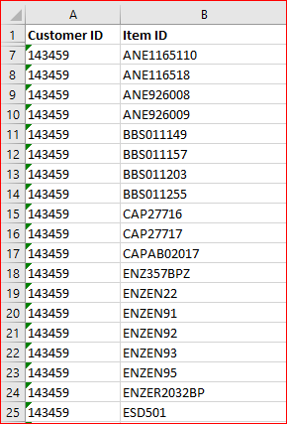

- Place the input file into “Input file” folder:
- NOTE: there are two instances of the Custom Price Generator for both Canada & USA. Each Instance has its own ‘Input & Output File’ folders.
- One Instance points to LIVE data and one points to the P21 database that is one day behind.
- The one labeled 901 is pointed to the P21 database that is one day behind.
- Use the 901 instances during the day, there is no limit for file size when using this instance.
- If you require LIVE (same day) data, you must ‘Limit your File Size to 500 Item IDs’. This will ensure that we do not put a heavy load onto the system so that your query won’t interfere with the P21 Performance.
- If you need to run more than 500 Item IDs thru the LIVE instance, you must process the file outside of regular business hours.
- Whenever possible, use the one labeled 901 which is one-day behind.

  - Navigate to the desired Input folder, Click on the applicable link below and place the file created in Step1 into the folder:

- for Canada:
- \\p21app\P21Shares\Imports\AutopricingFiles901\DropFilesHere
- \\p21app\P21Shares\Imports\AutopricingFiles\DropFilesHere

- for USA:
- \\P21usapp\p21shares\Imports\AutopricingFiles901\DropFilesHere
- \\P21usapp\p21shares\Imports\AutopricingFiles\DropFilesHere

- Retrieve the results file from “Output Folder”

When the Customer Pricing Generator detects a new file in the Input Folder, it begins processing that file.
An output file is generated and placed in the Output Folder. Click on the applicable Output Folder Link below, per the Instance that you selected above (901 or Live):

- for Canada:
- \\p21app\P21Shares\Imports\AutopricingFiles901\PickupFileHere
- \\p21app\P21Shares\Imports\AutopricingFiles\PickupFileHere

- for USA:
- \\P21usapp\p21shares\Imports\AutopricingFiles901\PickupFilesHere
- \\P21usapp\P21Shares\Imports\AutopricingFiles\PickupFilesHere

The filename of the output file is identical to that of the input file. Any pre-existing files in the Output Folder by the same name will be overwritten by the process.

Output File Specification
The output file shall be an Excel (.xlsx) file with one sheet (tab). The spreadsheet will contain a header row followed by data rows corresponding to the input file data. The spreadsheet will contain the following columns:

- If any errors were encountered while trying to resolve the output for the row, they will be described in column A

