Questions/Support: Jim Rudolph

jrudolph@dgisupply.com

Abstract

The Rubber Tree CRM system allows users to manage their customer contacts, create sales opportunities for the pipeline, check stock, issue quotes, and more!



**Operating Manual**

**Rubber Tree Systems - CRM**

**Rubber Tree CRM – User Manual**

The Rubber Tree portal is a web based sales tool focused on assisting salespeople in managing their customers, prospects, contacts, and sales opportunities. Initially, we will be focusing on getting the sales pipeline setup and operational. After that, we will work on building out robust customer and contact data.

**Getting Rubber Tree on your Phone or Tablet**

1. Go to your Safari browser app and type in the Rubber tree Login address <https://p21.rubbertreesystems.net>
2. At the login screen Tap the Share button at the bottom of the screen and then select the “Add to Home Screen” option. This creates a button on your phone or tablet that you can use to launch the app more easily.

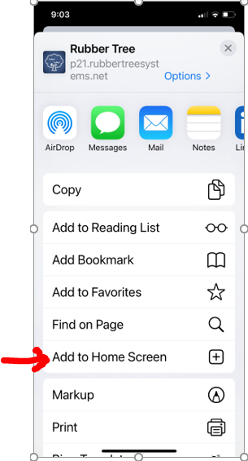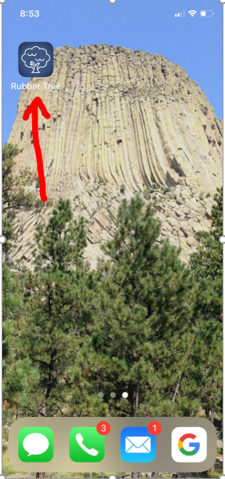

**Logging In**

To Log into Rubber Tree each user should use their primary DGI Supply email address. US users would use dgisupply.com email and Canadian users should use their dgisupply.ca email address. The default password assigned to ALL users is DoALL1480! Users should change this after logging in.

Login Link: <https://p21.rubbertreesystems.net/Account/Login>

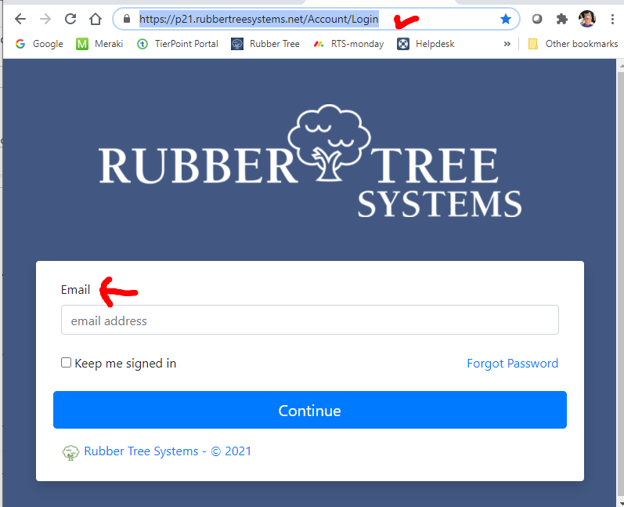

Users may also click on the “Forgot Password” link on the main login screen.

Once logged in the users can access the menu by clicking on the 3 lines in the upper left-hand corner of the screen

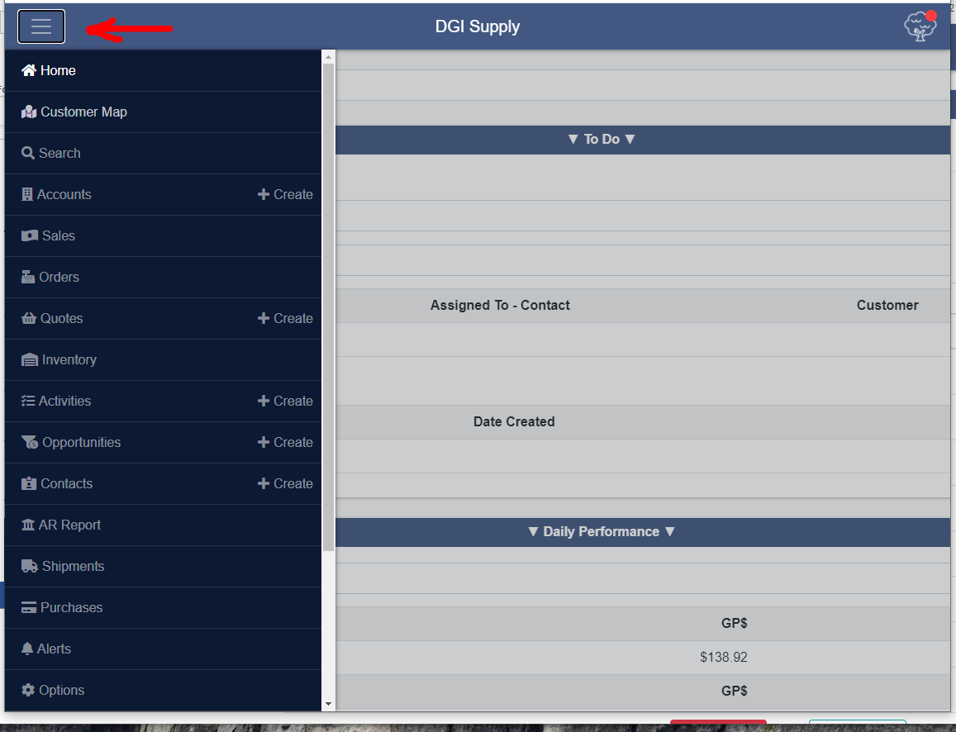

Menu Options Include:

**Home** -This is the main landing page you will see once you are logged in. Here is a short video tutorial [**https://youtu.be/uYpdT7MSJK4**](https://youtu.be/uYpdT7MSJK4)

**Customer Map** – This will allow a user to display customers on a map and to create routes to visit them. Here is a short video tutorial [**https://youtu.be/NkOeQtS73QE**](https://youtu.be/NkOeQtS73QE)

**Search** – This allows the user to search for information such as a customer PO# or part number across all of rubber Tree. Here is a short video tutorial [**https://youtu.be/TrxXgQXN7Pk**](https://youtu.be/TrxXgQXN7Pk)

**Accounts** – This is information about the customers. Users will be able to create a prospect in Rubber Tree. Here is a short video tutorial [**https://youtu.be/5XdxP35Mn40**](https://youtu.be/5XdxP35Mn40)

**Sales** – This is information about sales invoices. Here is a short video tutorial [**https://youtu.be/pgrRXSY7uXc**](https://youtu.be/pgrRXSY7uXc)

**Orders** – This is information on open sales orders. Here is a short video tutorial [**https://youtu.be/KBu1PBhRk2M**](https://youtu.be/KBu1PBhRk2M)

**Quotes** – This is information about open quotes. Here is a short video tutorial [**https://youtu.be/Ri0_T-LteSM**](https://youtu.be/Ri0_T-LteSM)

You can also enter NEW quotes with more detailed steps shown below.

**Inventory** – This is information showing inventory availability across all P21 locations. Here is a short video tutorial [**https://youtu.be/xazOV83cgh0**](https://youtu.be/xazOV83cgh0)

**Activities** – These are activities which are used to create tasks in furtherance of the sales opportunities created.

**Opportunities** – These are sales opportunities currently in the pipeline. The user can create or change these. More detailed steps are shown in the Supplemental Instruction area below.

**Contacts** – This is where the user will add/change individual contacts for each customer or ship-to.

**AR Report** – This will display the open AR for a customer. Here is a short video tutorial [**https://youtu.be/dhNKHCd8CSE**](https://youtu.be/dhNKHCd8CSE)

**Shipments** – These are the past shipments of products you may wish to review. Here is a short video tutorial

[**https://youtu.be/EhV8rhw4xuo**](https://youtu.be/EhV8rhw4xuo)

**Purchases** – These are open purchase orders from the suppliers

**Alerts** – These are user definable alerts which can be used to alert the user to specific events such as all quotes over $1,000. These get evaluated every hour so the results will be grouped to only those occurrences in the last hour.

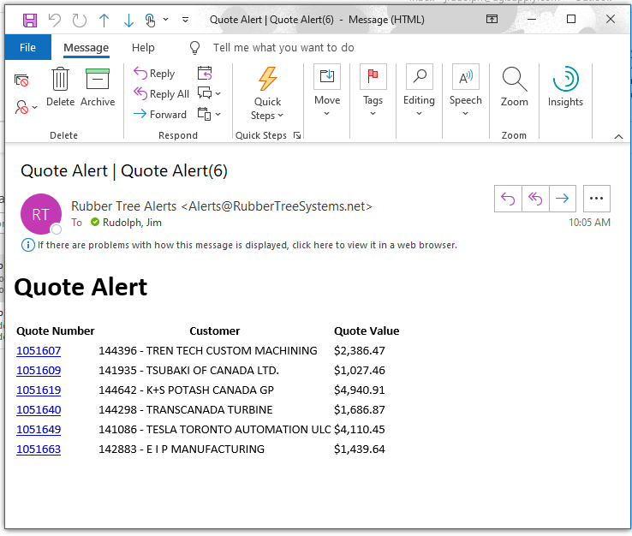Here is a short video tutorial [**https://youtu.be/nKndgjdyt4g**](https://youtu.be/nKndgjdyt4g)

**Options** – This is where the user may change their password as well as access the help system. Many of the common tasks are shown using You Tube video’s

**Log off** – This will log the user out of Rubber Tree

**Supplemental Instructions**

**Create NEW Contact**

To create a new contact, select the “Contact” option from the Navigation Menu and then click on the + Create Contact button.

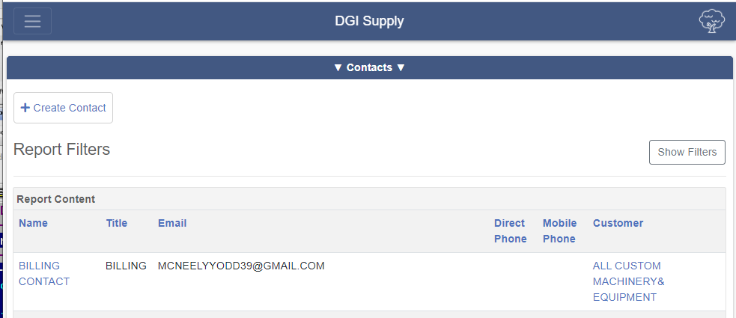

Contacts can be attached to specific customers OR to specific P21 ship-to records. Ideally, you should create the contact at the customer level. Then once saved, the user can specify which of the customer ship-to’s the contact ALSO is associated with.

Below is the blank form you will use.

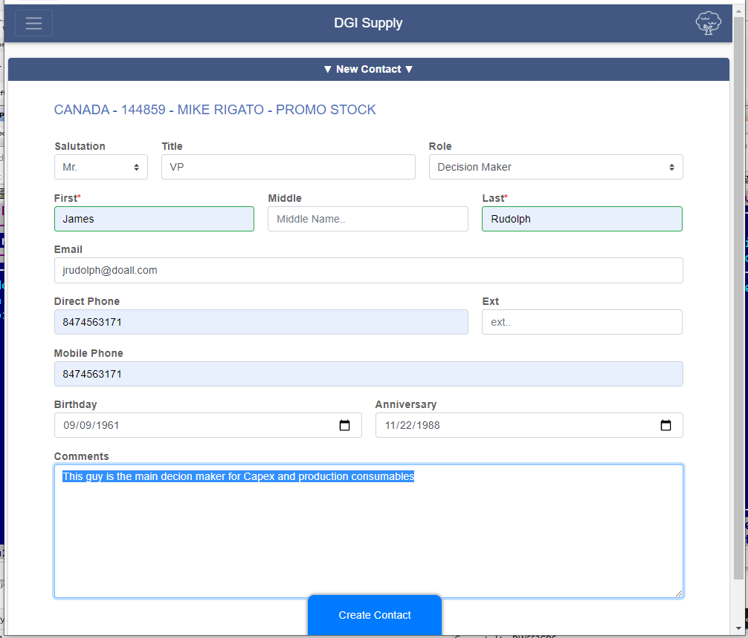

Under the “Role” drop down the user will have several options

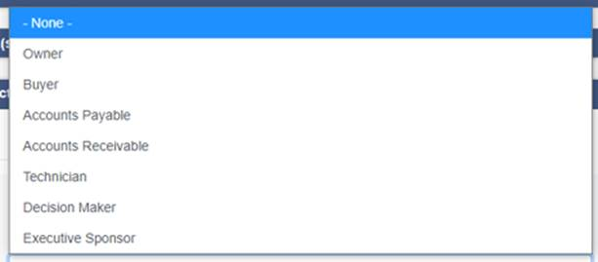

Once all fields are filled in, the user should click on the Blue “Create Contact” button.

To edit an existing contact the user can search for the desired contact and make the necessary changes using the same screen.

The user may also disassociate a contact from a customer by unchecking the “Assigned to Contact” checkbox

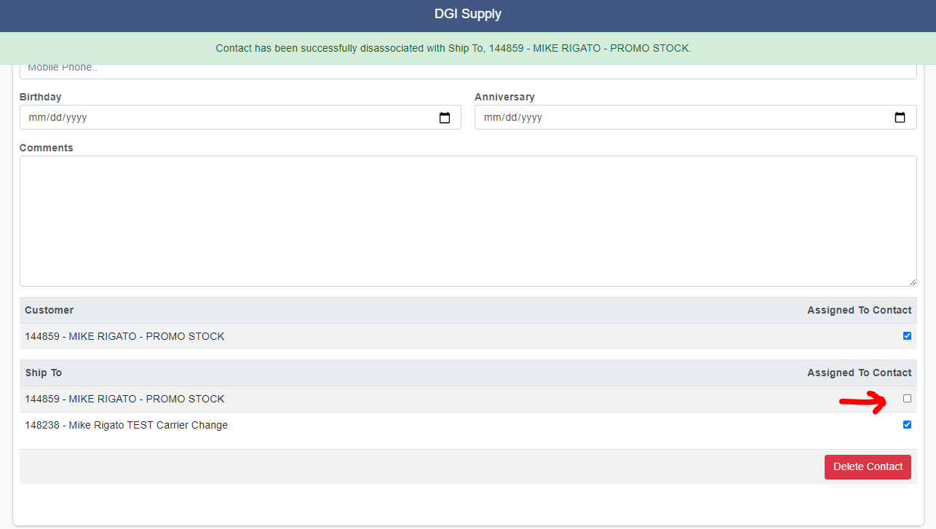

**Create a New Quote**

Below is the quote form header. Once this is completed, the user should click the Blue “Start Quote” button to add the line items. Once submitted, these will show up in P21 in about 15 minutes. To email the quote, the user must wait for the quote to go to P21 to be created and returned to Rubber Tree. At that time the user may go back into the quote in Rubber Tree and click on the “Download PDF” button to display the PDF quote. The user may then click on the share button to email it.

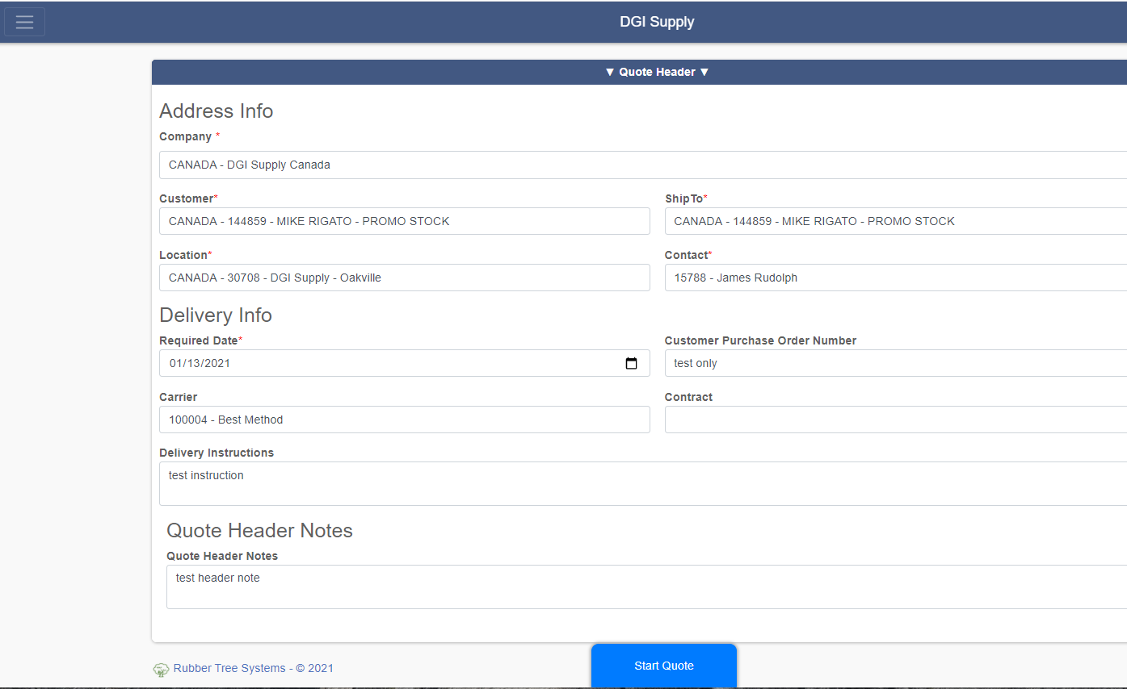

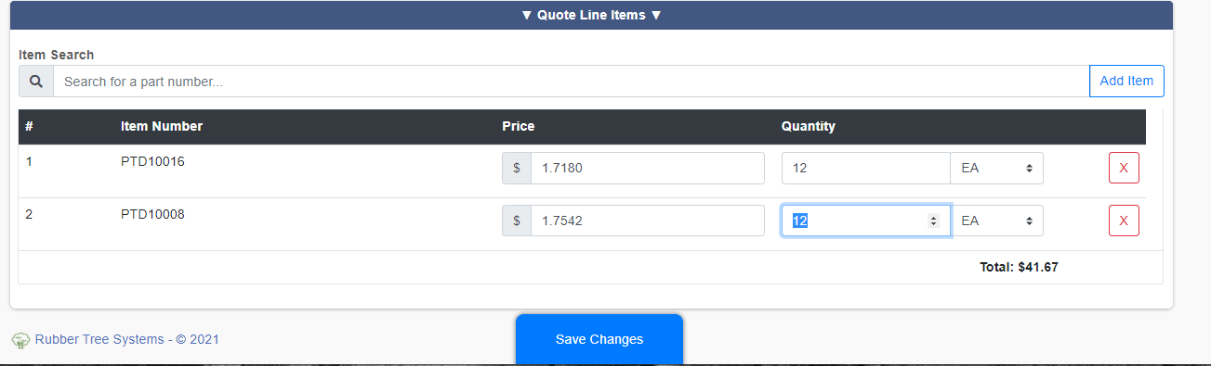

**Create NEW Activity Task**

Below is the task form. Tasks are activities which are assigned to a specific contact in furtherance of the sales opportunity. The user has the ability to create reminders and Outlook Calendar events if desired by clicking on the “Download Calendar Event” button at the bottom of the form. The various types shown below.

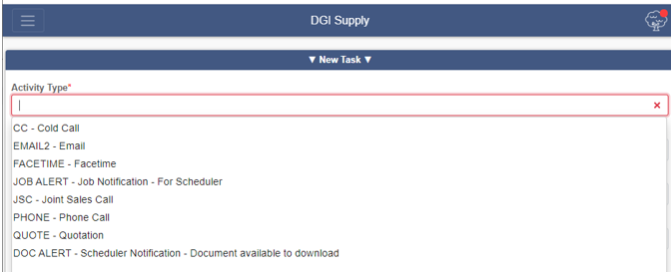

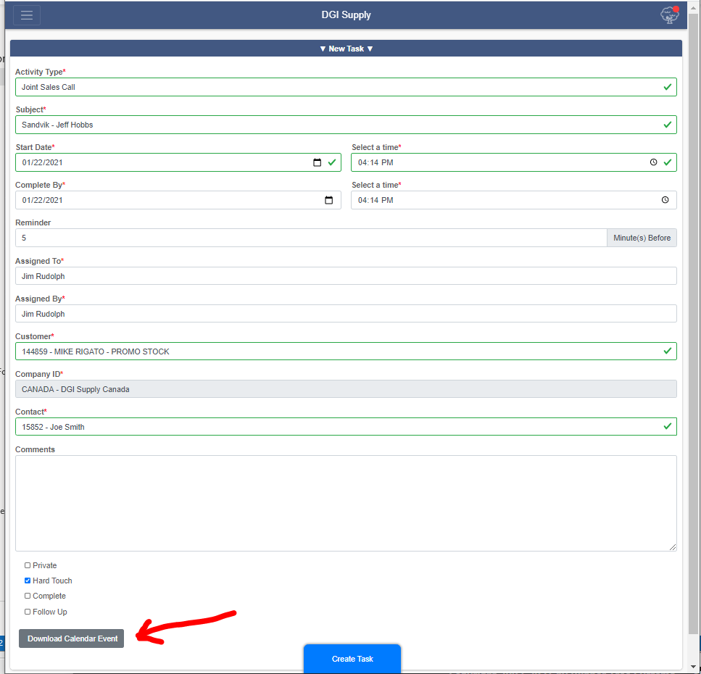

**Create NEW Sales Opportunity**

Below is the NEW Sales Opportunity Form. The user should fill out all fields and click on the blue “Update Opportunity” button to save it. ALL APS Opportunities will be entered and progressed by the APS sales team. The account managers and DSM’s should not enter or make changes to these opportunities.

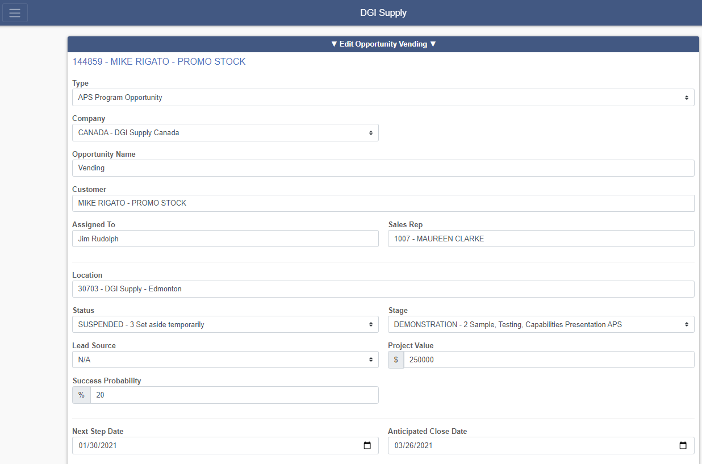

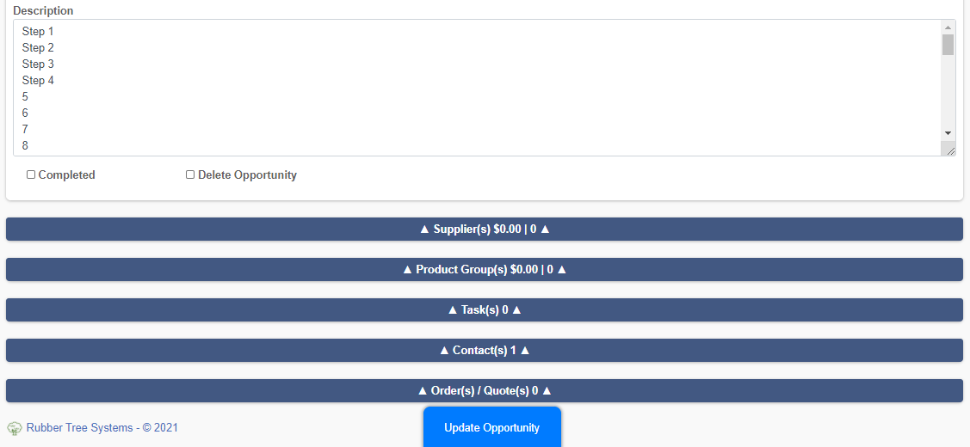

**Create NEW Prospect**

Below is the NEW Prospect form. The user can create sales opportunities for a NEW Prospect however, will need to message internal staff to convert a prospect to a P21 Customer before a sales order can be entered. 