How to access the DoALL Terminal
Windows XP/7
- Navigate to Start > All Programs > Accessories > Remote Desktop Connection
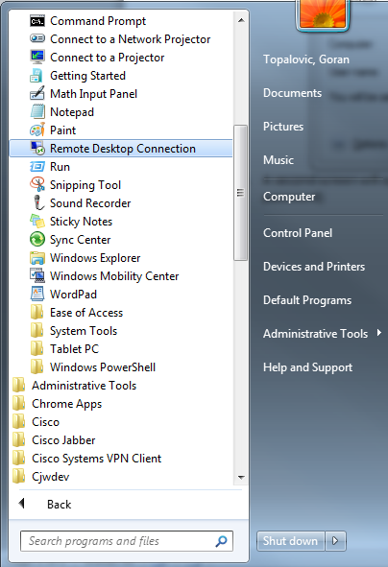
- Enter “terminal.doall.com”
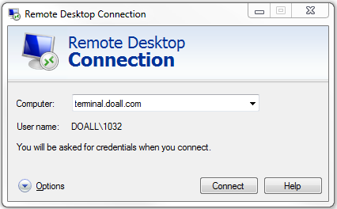
- A second screen will open up and ask for credentials. Enter in your windows login (4 digit id, and password)

