Credit Card PO Process
- Before generating the Credit Card vendor purchase order, make sure to enter the vendor information in the PO header. The address is not as important as a contact name along with email or phone number.
- Do not use the vendor number if it comes up in the “VI” prompt. Use vendor number “111111” or the three letter code of “ *DJI “.
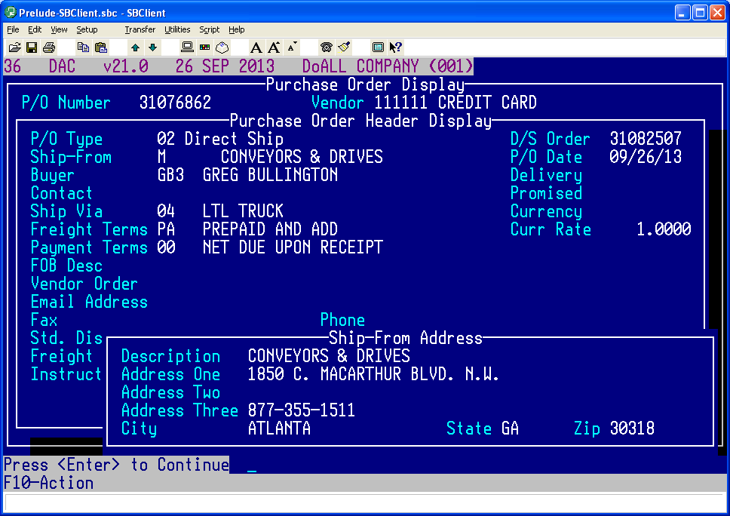
- Generate the purchase order (B or D). The “B” rule does not apply to Credit Card vendors when generating purchase orders for CC vendors.
- Place the order with the vendor (and send the actual PO to vendor) and advise that they will be contacted with DGI’s credit card information. All details about the order, whether special shipping instructions, pricing, etc., should be complete before emailing doallCC@doall.com. Instruct the vendor to email the invoice to doallCC@doall.com and add this as a comment line on the PO.
- Obtain confirmation from vendor to ensure that the order is complete as the Wheeling contact will not be able to answer product related inquiries from the vendor. An incomplete and unconfirmed PO will be returned to the CSR delaying the order process.
- Confirm that the vendor will NOT charge sales tax. A copy of the uniform resale exemption certificate can be obtained from emailing “DGI Forms.”

- Email a copy of the purchase order to: doallCC@doall.com with the subject line “CC PO#XXXXXX”. For web based orders, please be sure to also include a screenshot of the product including model number and other identifying information. Include the name of your vendor contact, if applicable, and how the PO was sent to the vendor (i.e., fax, email or phone). This email box will be monitored by the Wheeling contact Monday thru Friday between the hours of 7:30 a.m. to 4:00 p.m. CST. (If the Wheeling contact is out of the office, the email box will be monitored by a designated back-up.)
- The Credit Card vendor will be contacted within one business day of the purchase order submission.
- You will receive an email from doallCC@doall.com stating that the vendor was provided DGI’s credit card information.
- If the Wheeling contact is for any reason unable to contact and provide credit card information to the vendor, you will be notified within one business day. It is then your responsibility to follow-up on your order.
- Any correspondence, such as invoices, pertaining to your Credit Card vendor PO should be forwarded to doallCC@doall.com immediately with the subject line “CC PO#XXXXXX - INVOICE”, for example.
- CANCELLED ORDERS: If a portion or all of an order has been cancelled, please send an email to doallCC@doall.com with a subject line of “CC POXXXXXX – ORDER CANCELLED”.

