Outlook – Out of Office Replies

When setting your ‘out of office’ reply there are two tabs to populate; one for messages sent within the organization and one for sending replies outside the organization.
It is very important that you populate both so that outside personnel are receiving the correct information when you are away. See below for instructions.

How to turn on “Automatic Replies (Out of Office)” or the “Out of Office Assistant”
For Microsoft Office Outlook 2013 and 2010

1.Click the File tab, and then click the Info tab in the menu.
2.Click Automatic Replies (Out of Office).
3.In the Automatic Replies dialog box, select the Send Automatic Replies check box.
4.If you want to specify a set time and date range, select the Only send during this time range check box. Then set the Start time, and then set the End time.

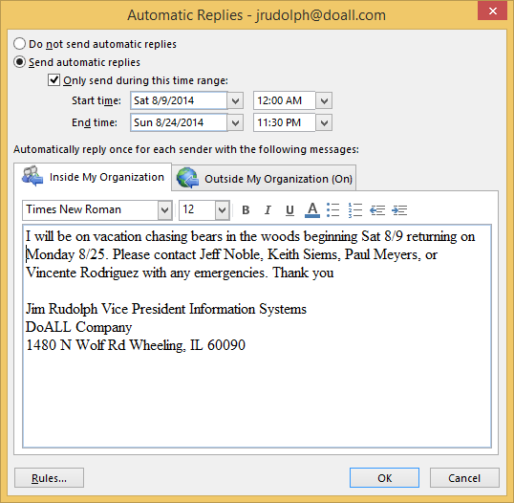

5.In the Inside my organization tab, type the message that you want to send within your organization, and in the Outside my organization tab, type the message that you want to send outside your organization.
6.Click OK.
7.If you selected the “Only send during this time range” option in step 4, the Automatic Replies (Out of Office) feature will continue to run until the date and time set for the End Time in step 5 is reached.
Otherwise, the Automatic Replies (Out of Office) will continue to run until you repeat step 1 and select the “Do not send automatic replies” option.

